**Bootcamp Project 1 - Data Pipeline for Customer Account Analysis**

**Project objective**

To design and implement a robust pipeline for processing customer account data. This involoves:

Copying data from backend teams’s storage account.

Performing necessary data transformations using Azure Data Factory.

Upserting data from Azure data lake storage gold layer into SQL database table.

The pipeline is intended to ensure efficient,accurate and scalable data processing to support downstream analytics and reporting needs.

**Architecture of Customer Account Analysis**

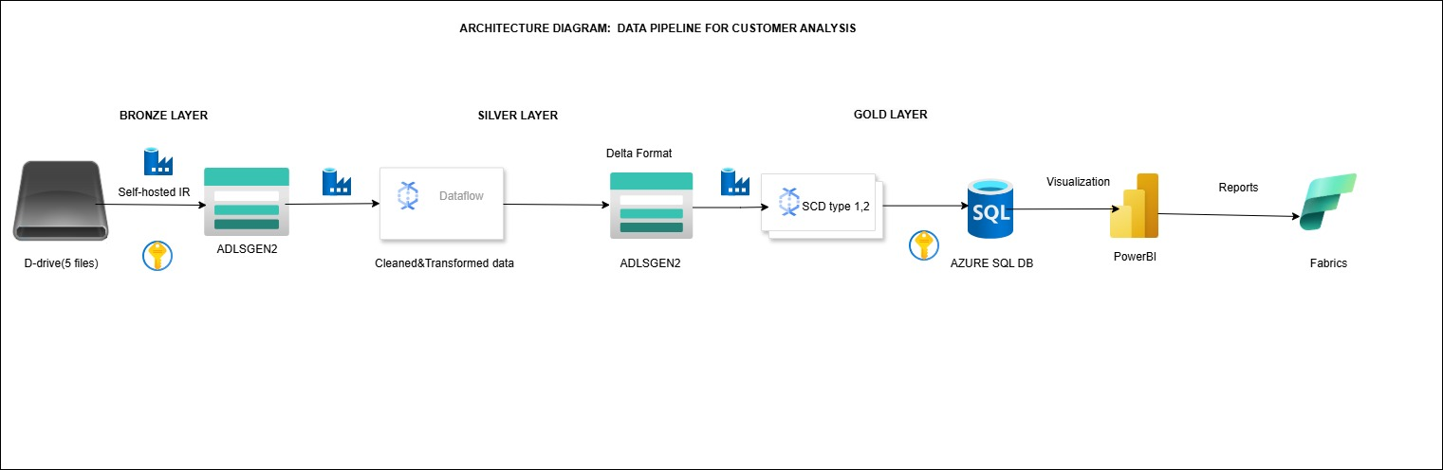

**Process**

**Data Ingestion (Backend Storage to Raw(Bronze) Container)**

Configure an Azure Data Factory (ADF) copy activity to transfer data from the backend team's storage account to your designated raw(bronze) container in the data lake.

1. The D-drive serves as the team's backend storage, and we need to migrate its data to ADLS Gen2. To accomplish this, set up a self-hosted integration runtime and configure it within the linked service.

Self hosted integration runtime will connect the onpremises data sources to Azure cloud services.

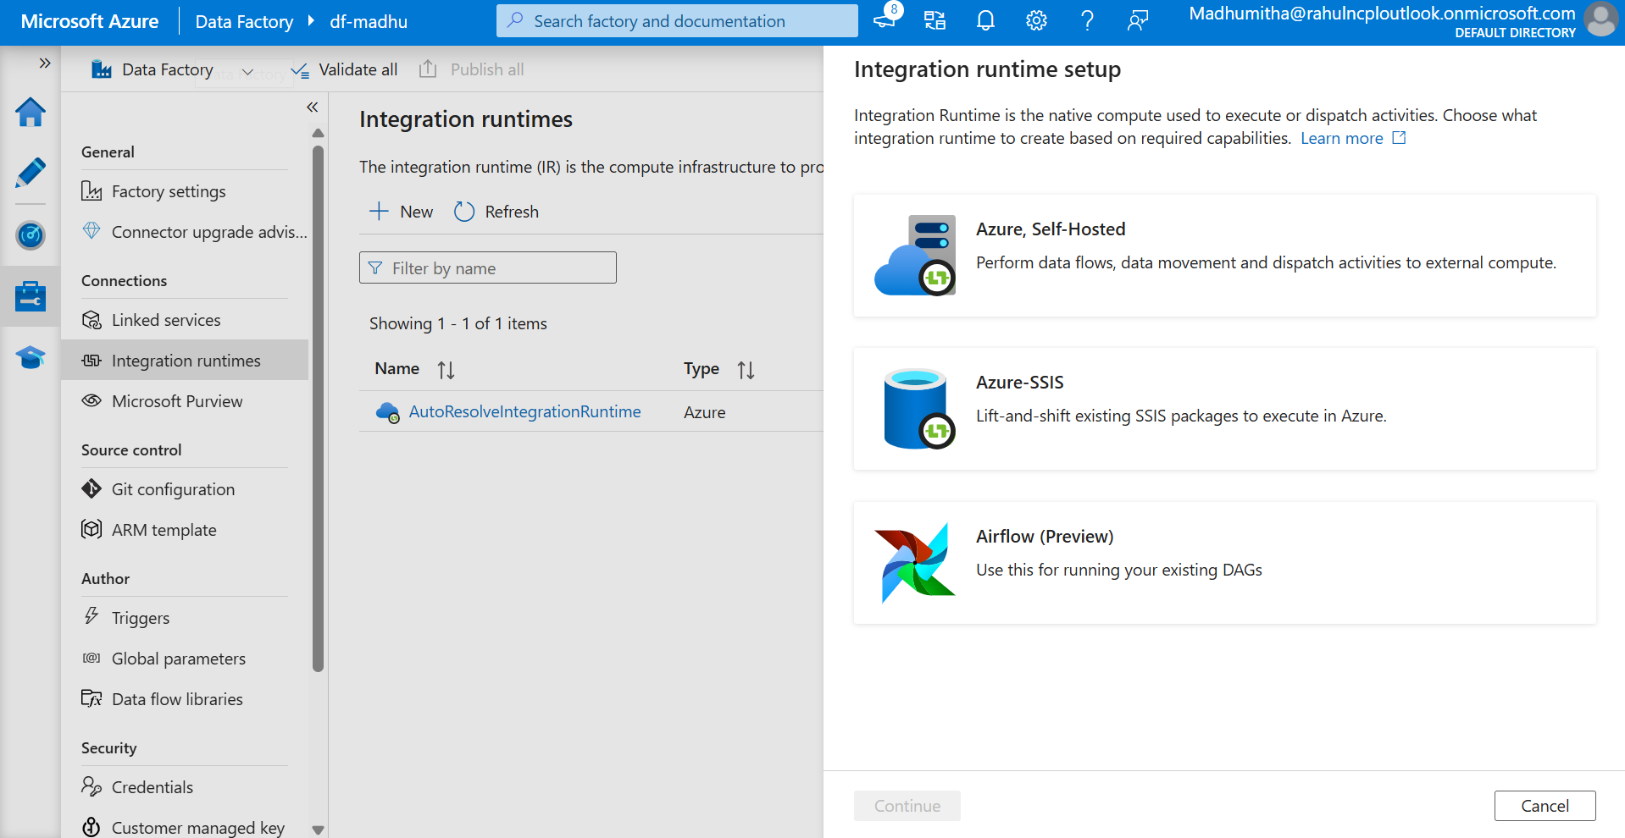

2.Select self-hosted IR from the listed option and create it.

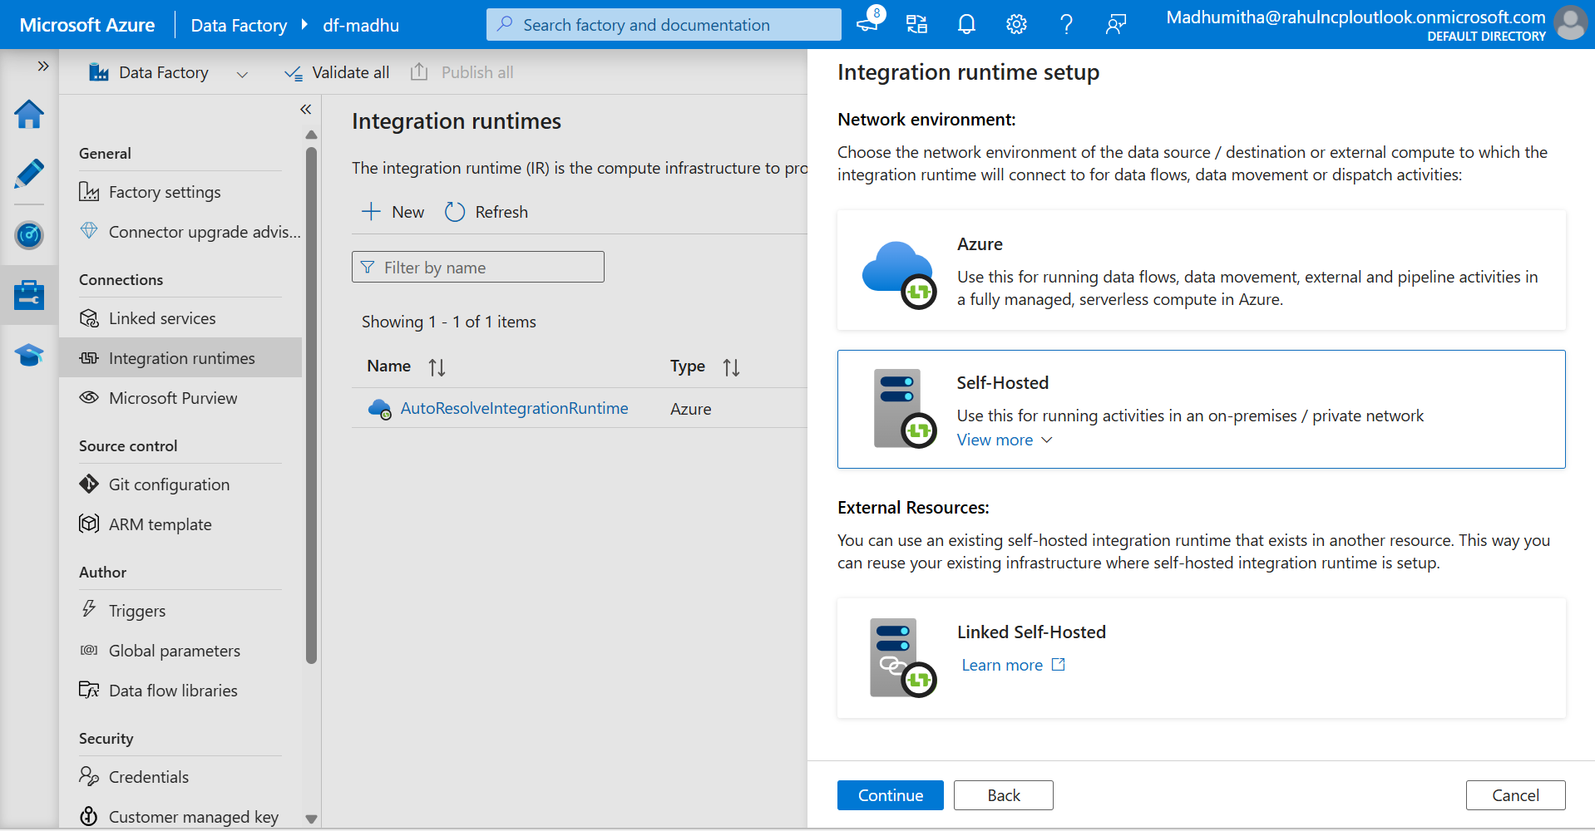

3.Navigate to manage tab in ADF and create self-hosted IR in IR setup. Copy the keys for your reference.

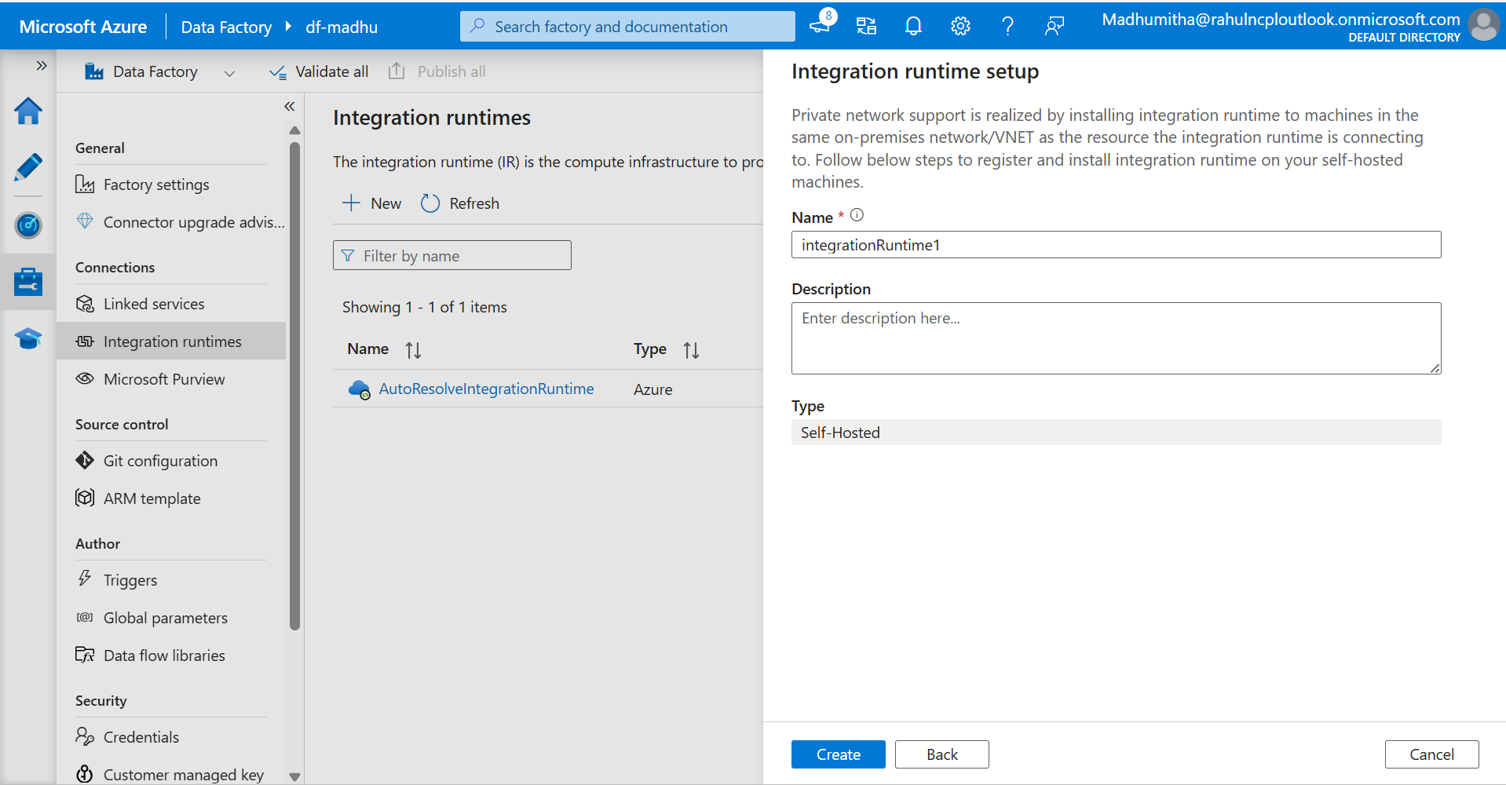

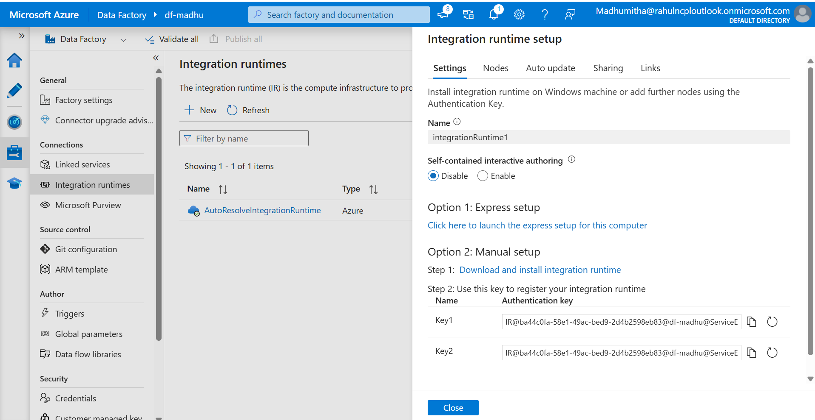

4.Download and install self-hosted IR from google chrome and use the keys for registration purpose

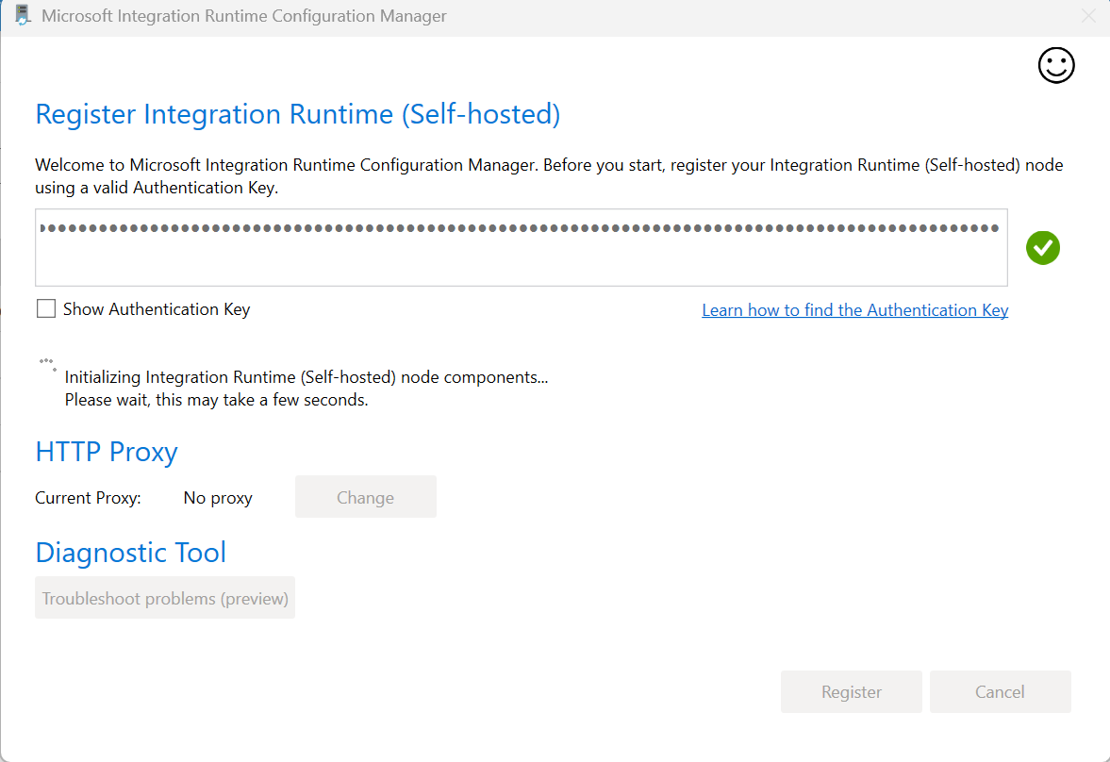

Key 1-IR@ba44c0fa-58e1-49ac-bed9-2d4b2598eb83@df-madhu@ServiceEndpoint=df-madhu.canadacentral.datafactory.azure.net@FxtD+YYAy16mI4Bug64oNMfrgl1UarDLdrOtupCGGJc=

Key [2-IR@ba44c0fa-58e1-49ac-bed9-2d4b2598eb83@df-madhu@ServiceEndpoint=df-madhu.canadacentral.datafactory.azure.net@jIKFRTJg1fVugnMa5b8OkNSn1SxHNvtZf4qUbe5b8aM=](mailto:2-IR@ba44c0fa-58e1-49ac-bed9-2d4b2598eb83@df-madhu@ServiceEndpoint=df-madhu.canadacentral.datafactory.azure.net@jIKFRTJg1fVugnMa5b8OkNSn1SxHNvtZf4qUbe5b8aM=)

**BROZEN LAYER (Local systems to ADLSGen2)**

S1 – Create a pipeline named br_CopyAct in integration tab from ADF

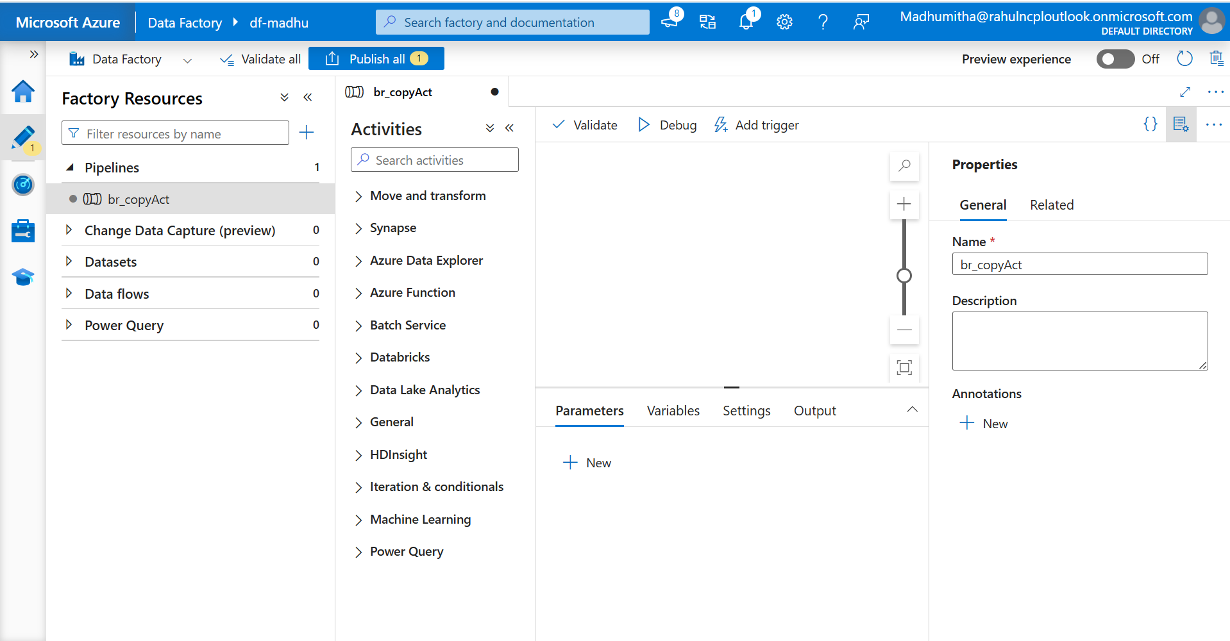

S2- Drag and drop the foreach activity

S3- Inside the foreach activity, drag and drop the copy activity.

S4 -In source, select file system from source dataset

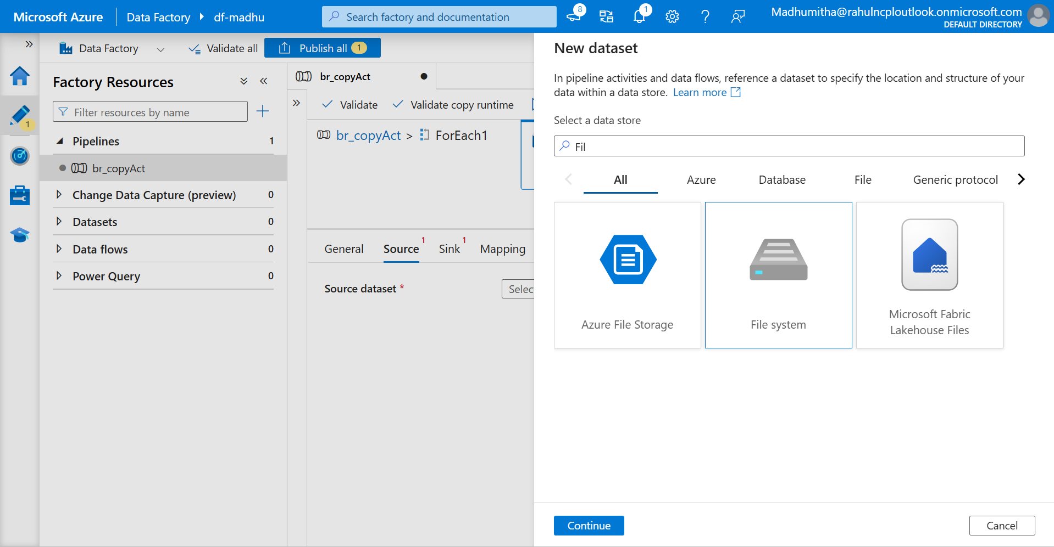

S5- select the format as csv

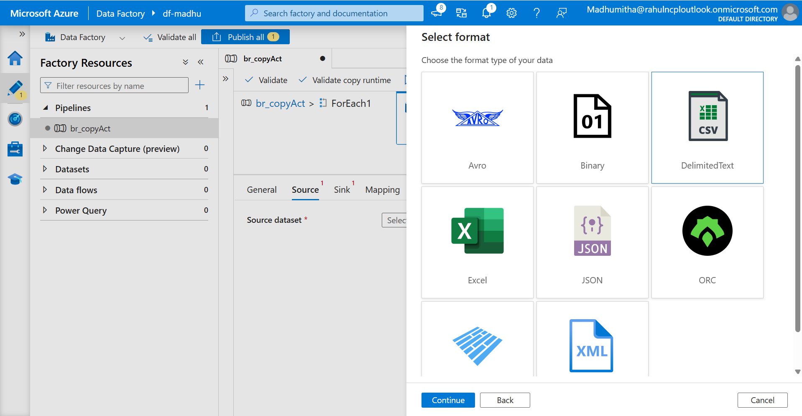

Issue- Connecting systems credentials in linked service

Workaround- Go to windowspowershell -> run as administrator -> use command cd "C:\Program Files\Microsoft Integration Runtime\5.0\Shared"

then .\dmgcmd.exe -DisableLocalFolderPathValidation use this command and wait for integration run time to connect then try to test connection

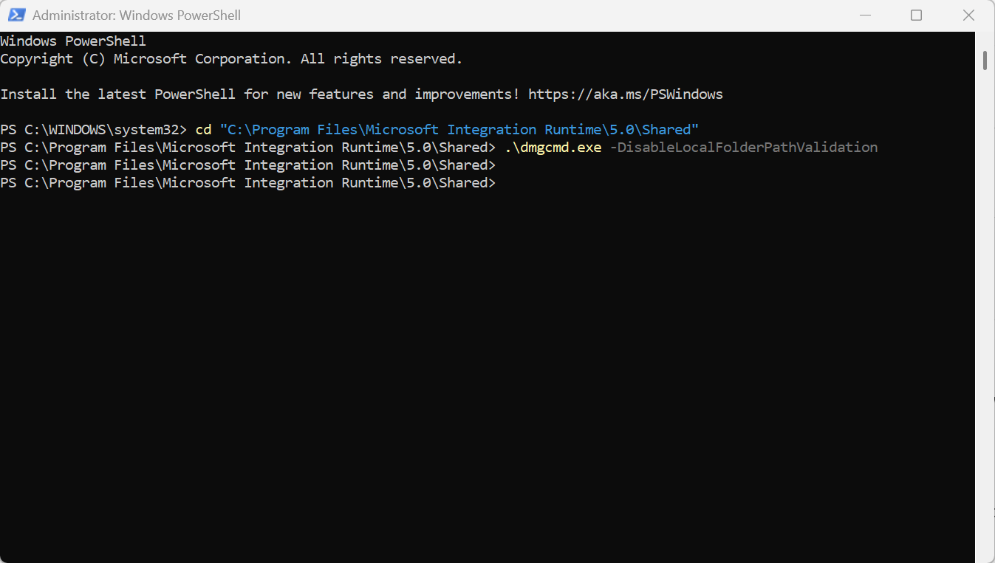

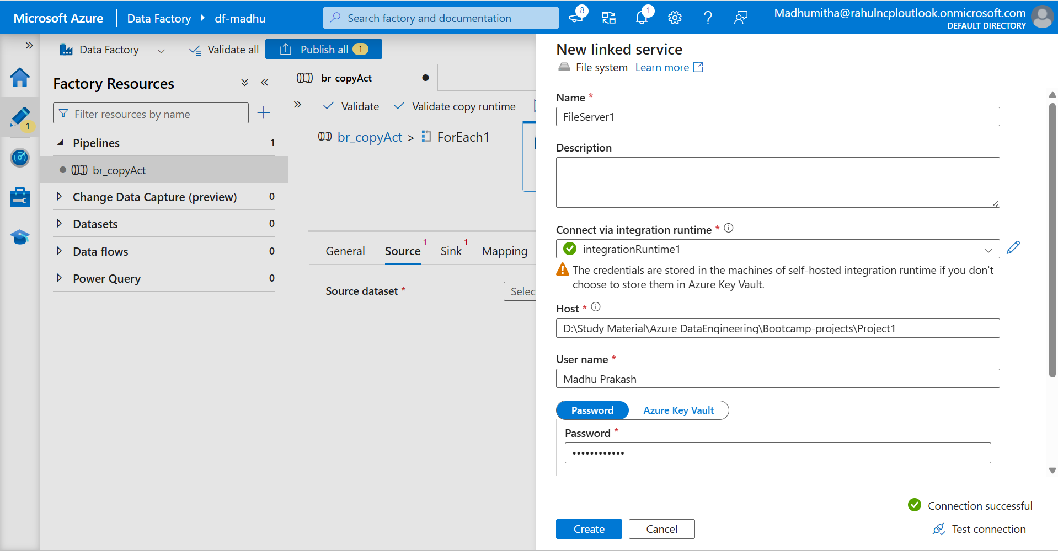

To connect D-drive with credentials, we are using Azure key vault for security purpose.

Create secret keys to save the d-drive credentials.

S6- Go to Key vaults, add secret keys by clicking the generate/import from secrets.

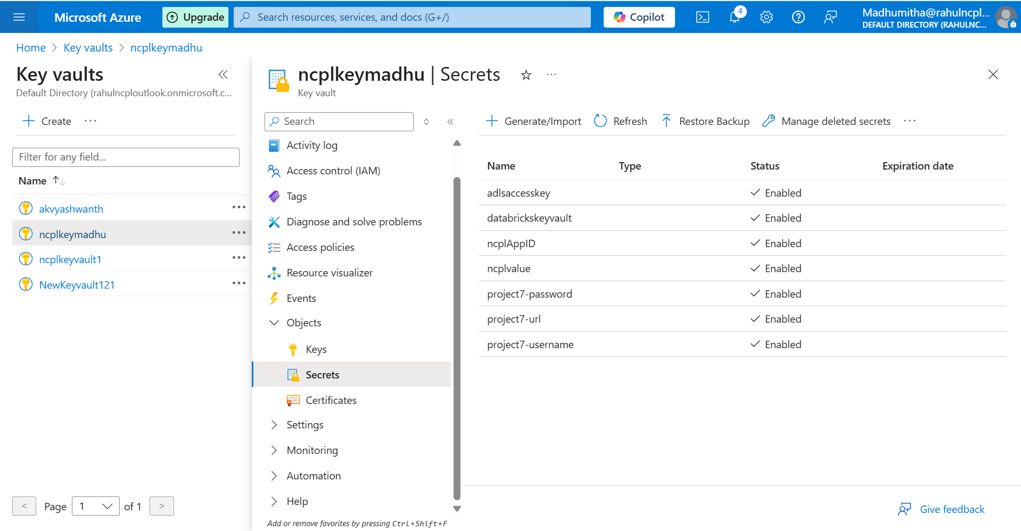

S7 – create d-host and d-password by creating from generate/import.

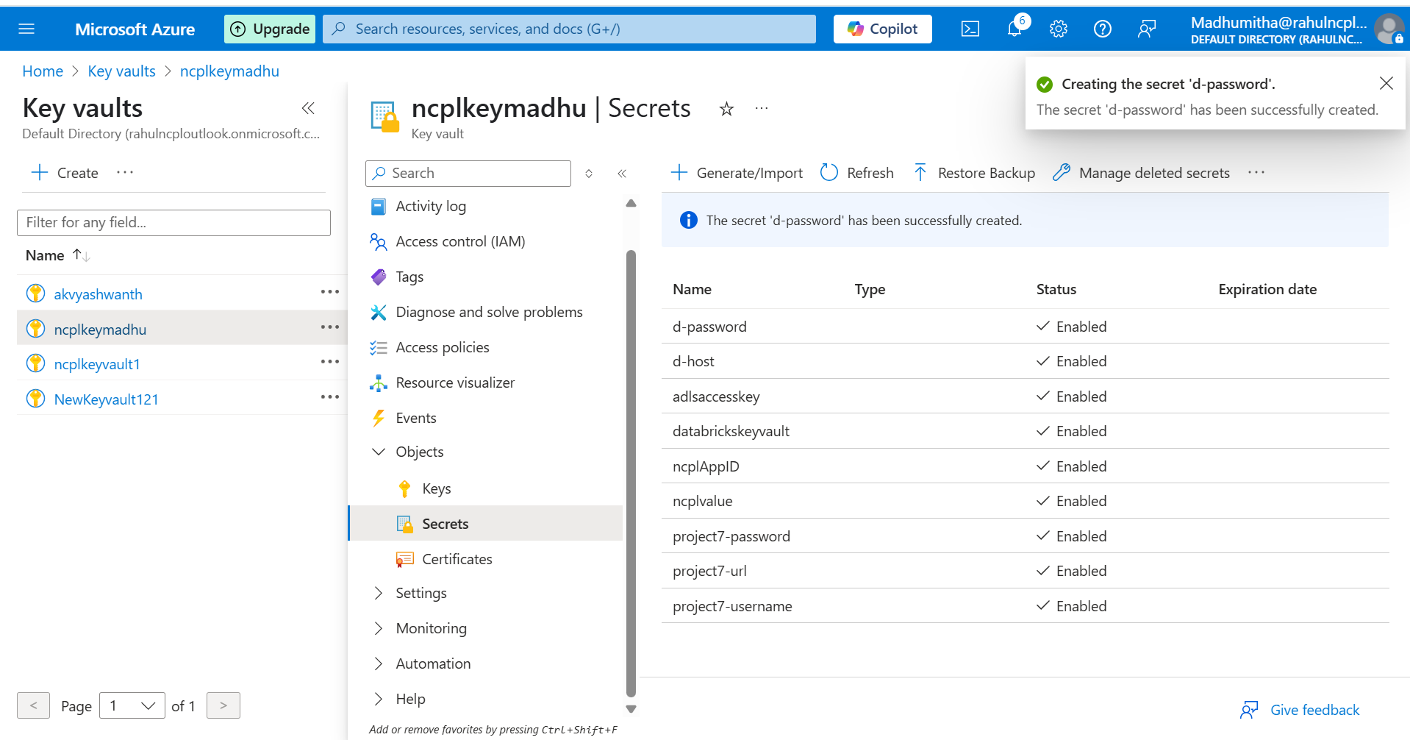

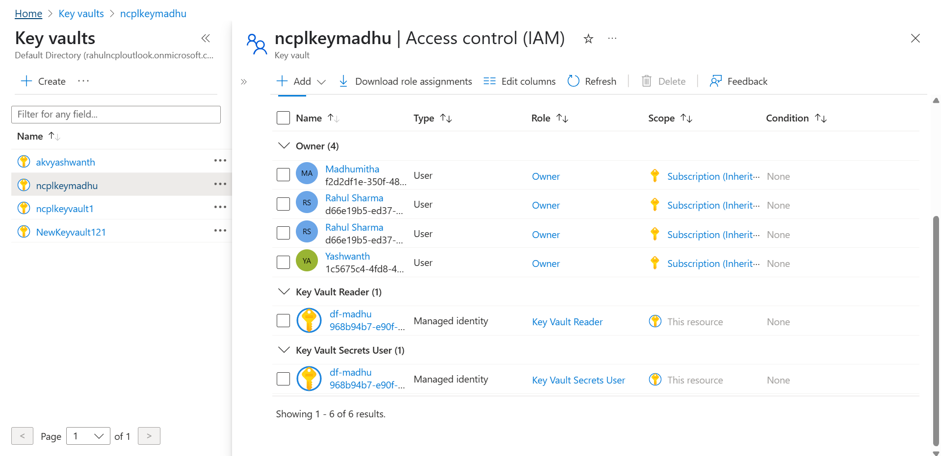

It may still throw a permission error. To resolve this, navigate to the Access Policies and enable "Get" and "List" permissions under Secret permissions.

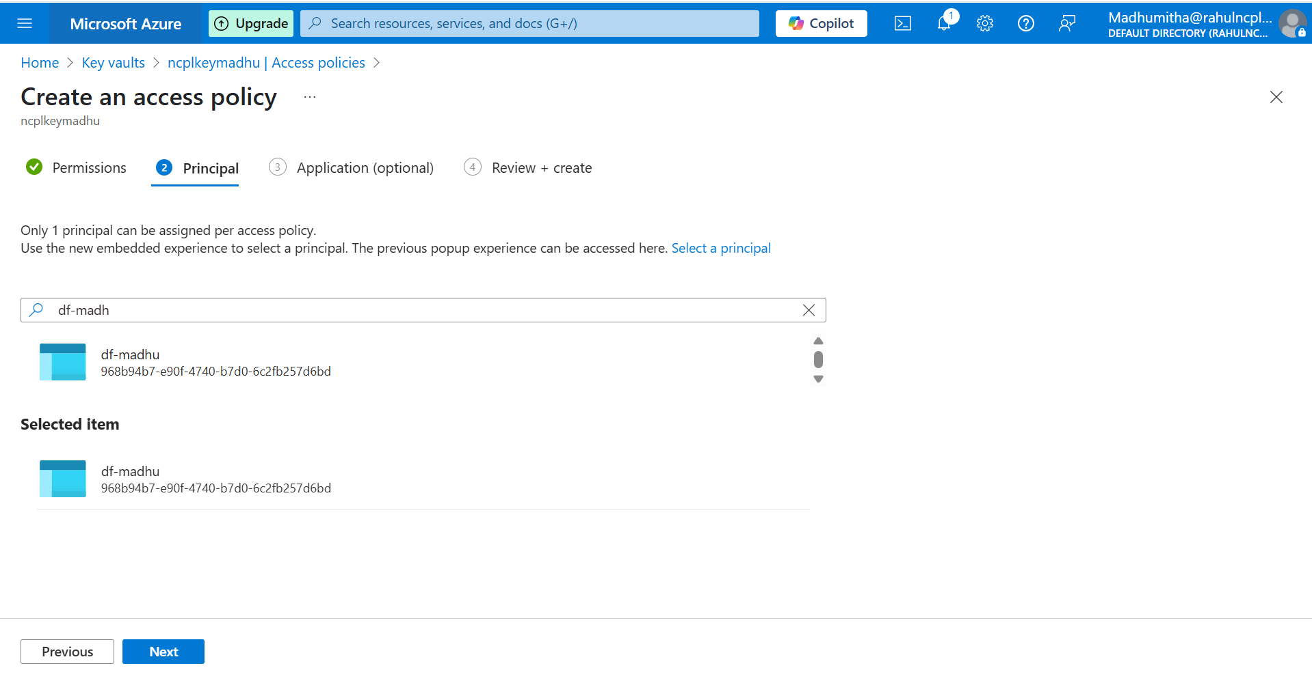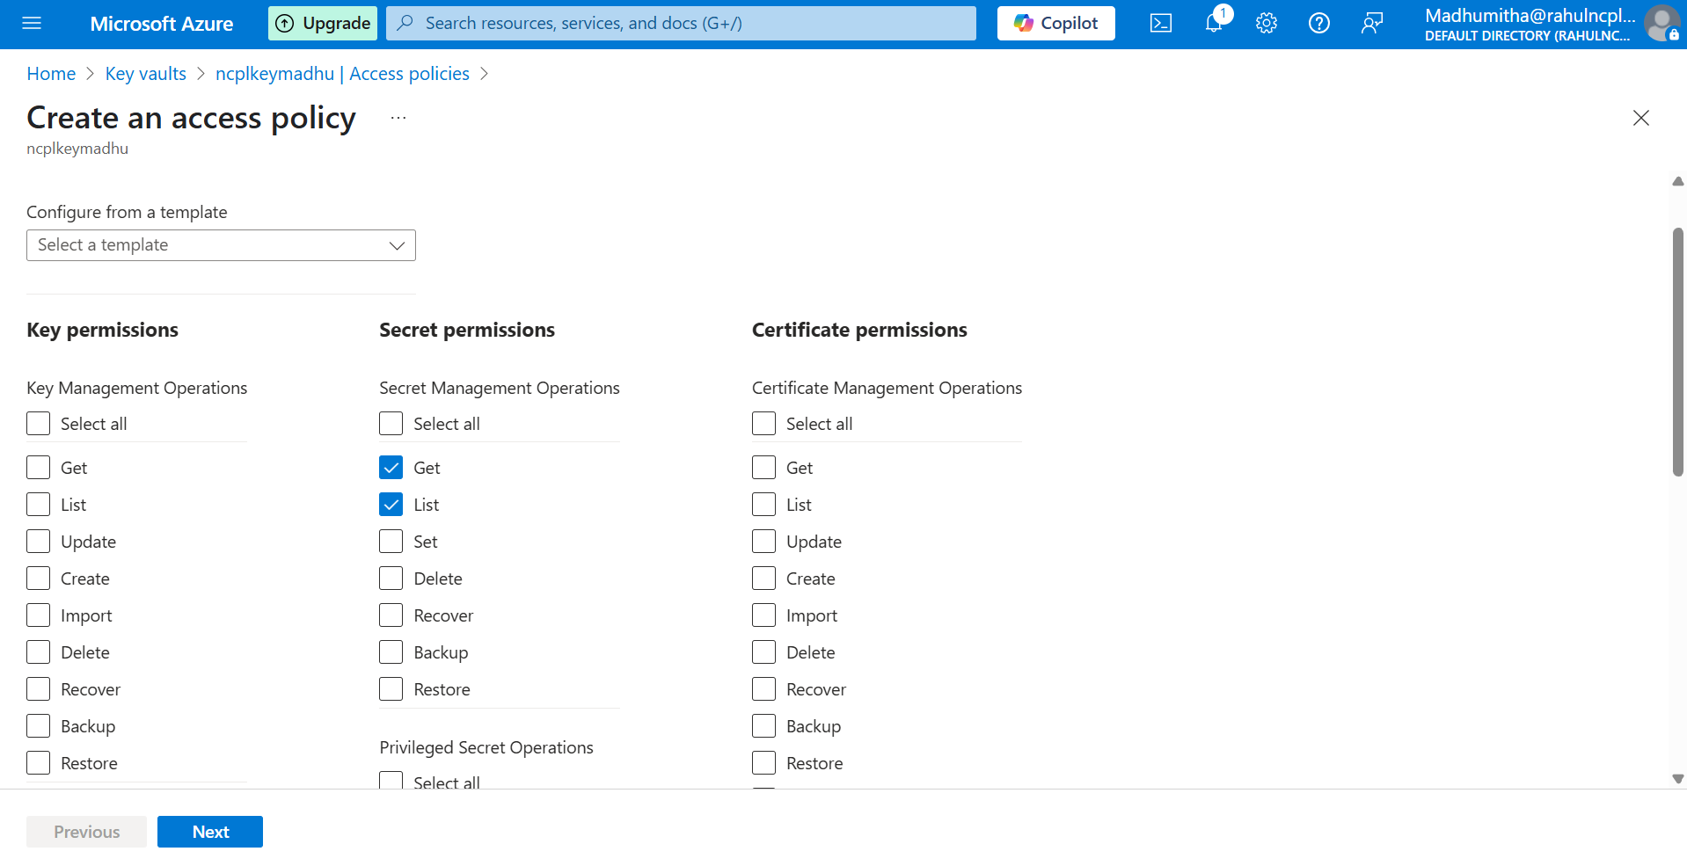

S8-Now, in linked service, choose Azure key vault and test connection

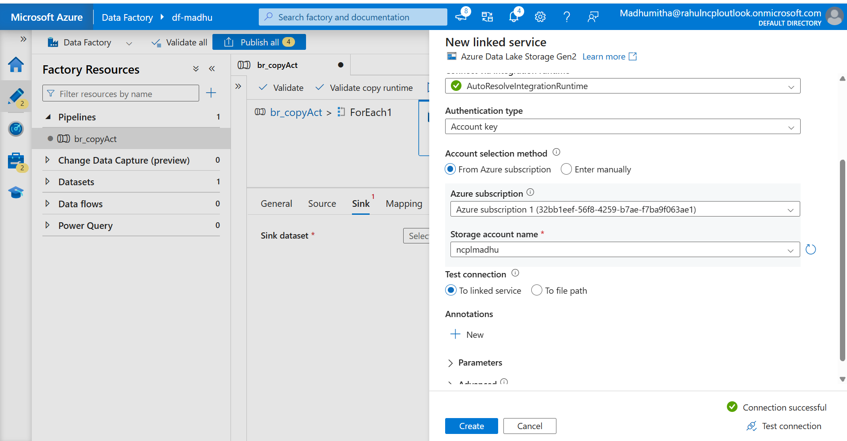

S9-In sink, browse the file path to dump the files in ADF

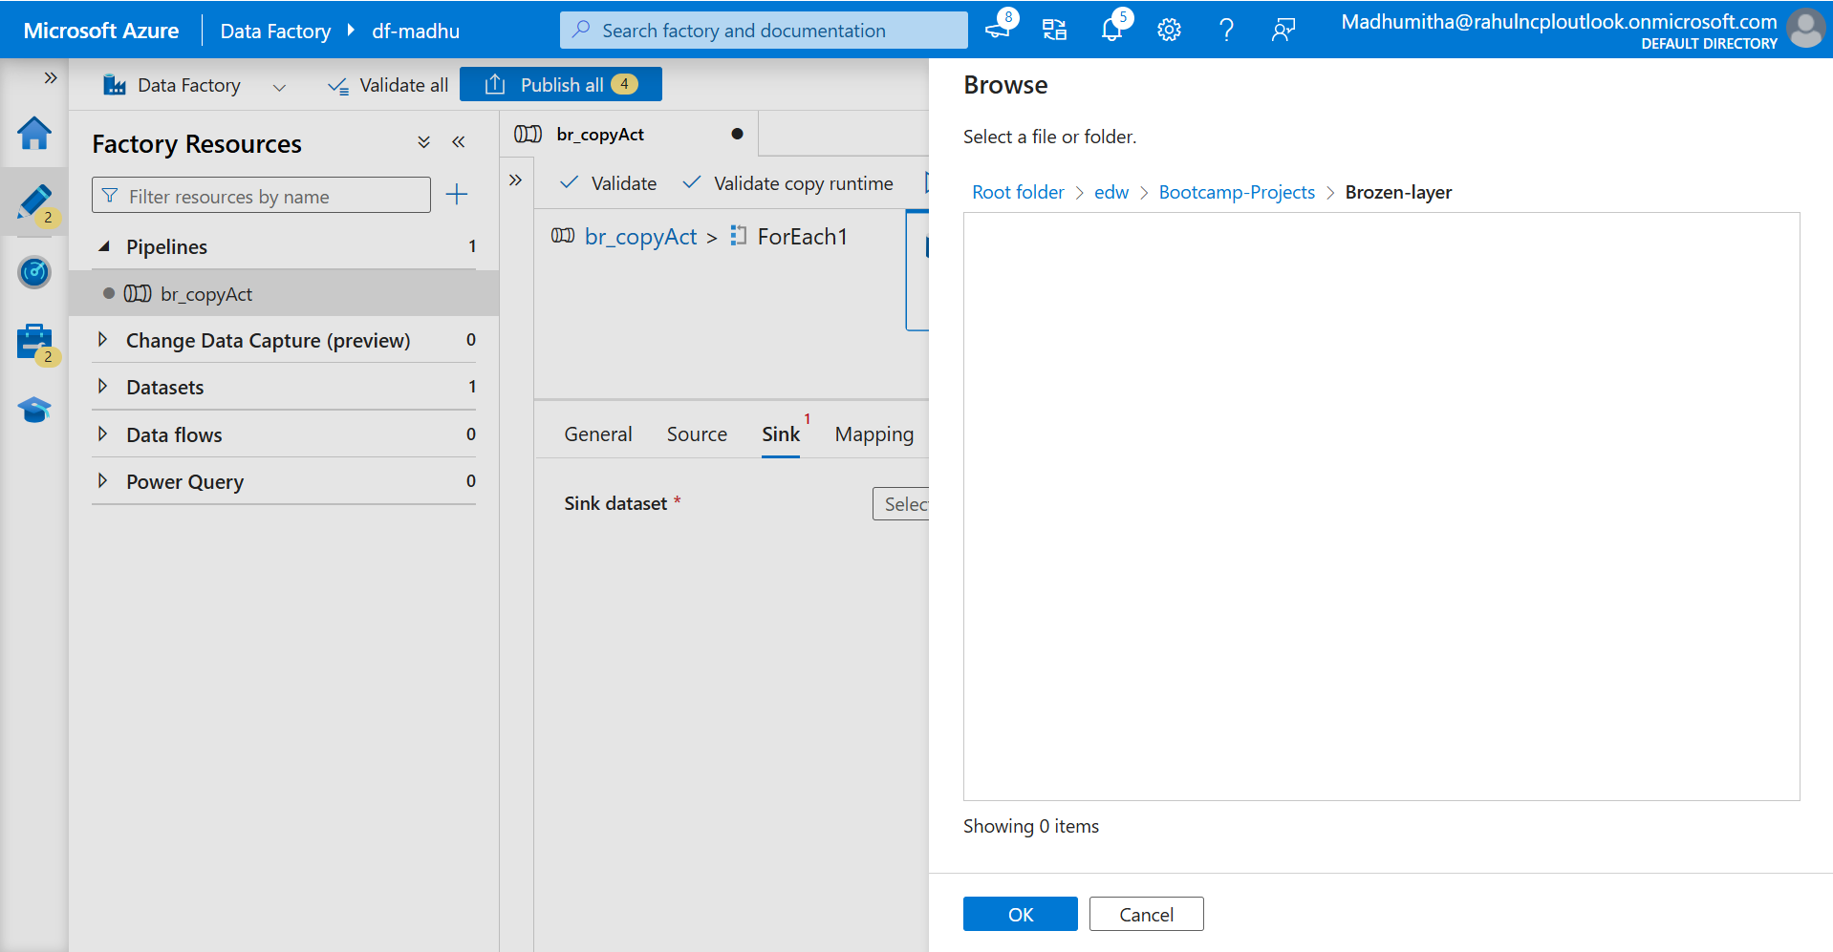

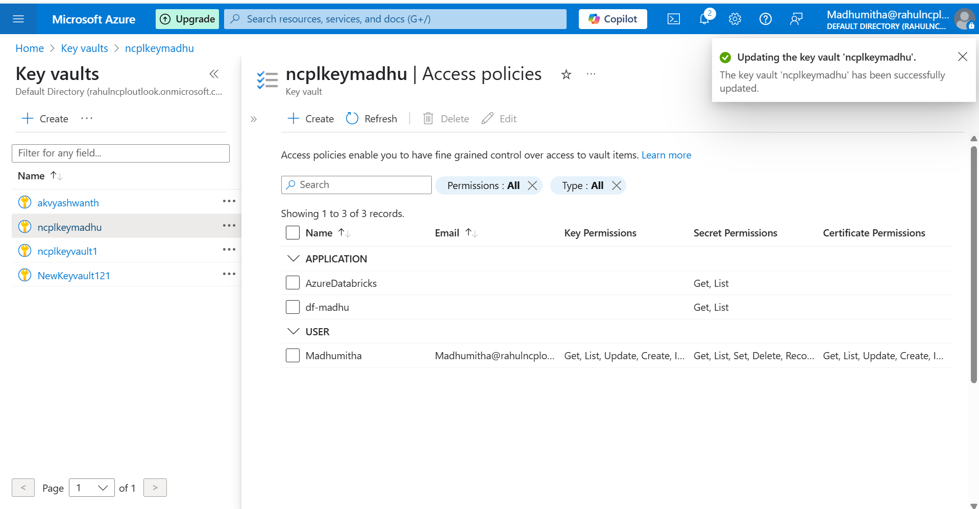

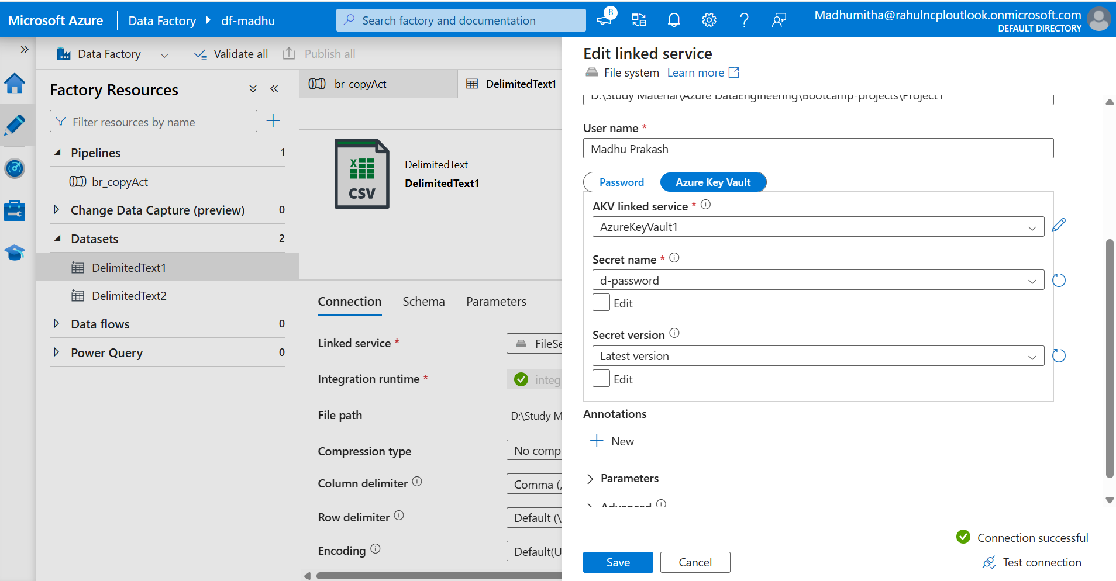

S10 – Publish and run the pipeline and check the adlsgen2 to access the files.

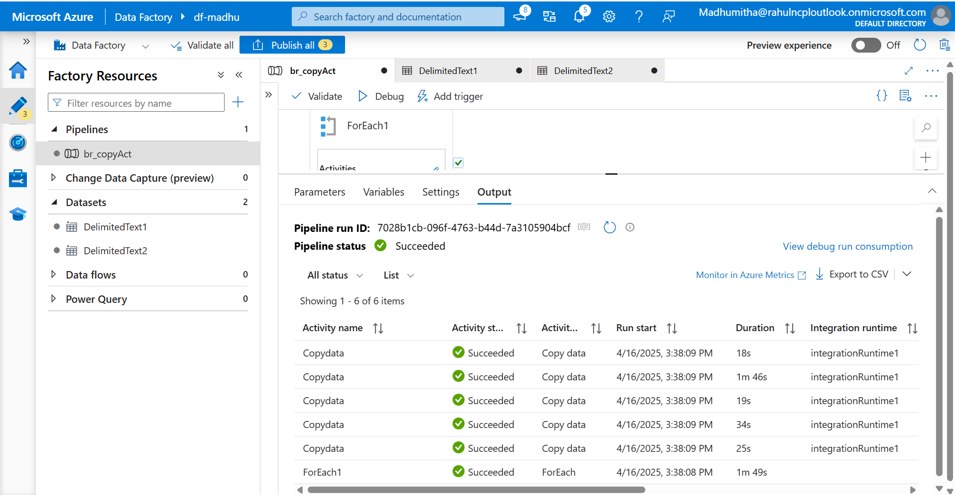

Go to the ADLS Gen2 storage account and verify that the files have been successfully loaded.

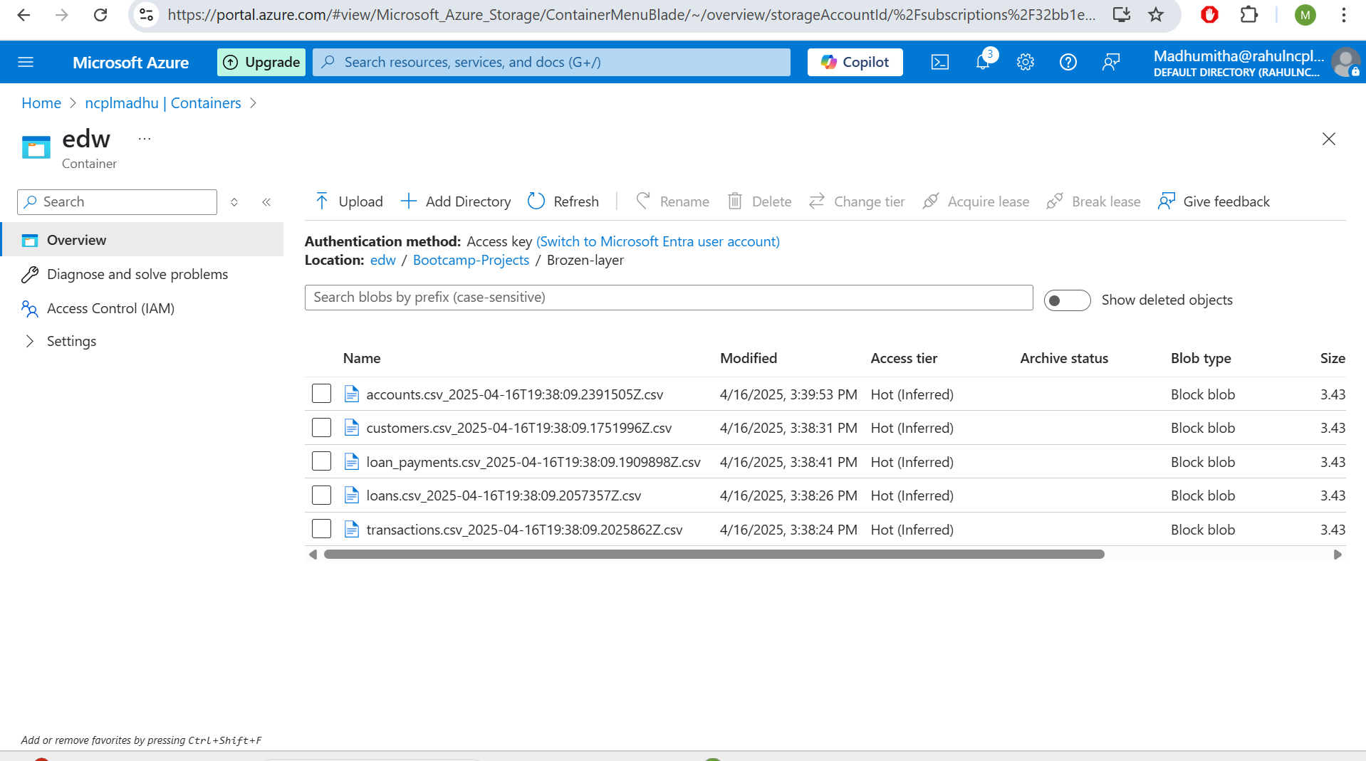

**SILVER LAYER**

**Use ADF dataflows to remove duplicates**

S1- Drag and drop the dataflow and click new.

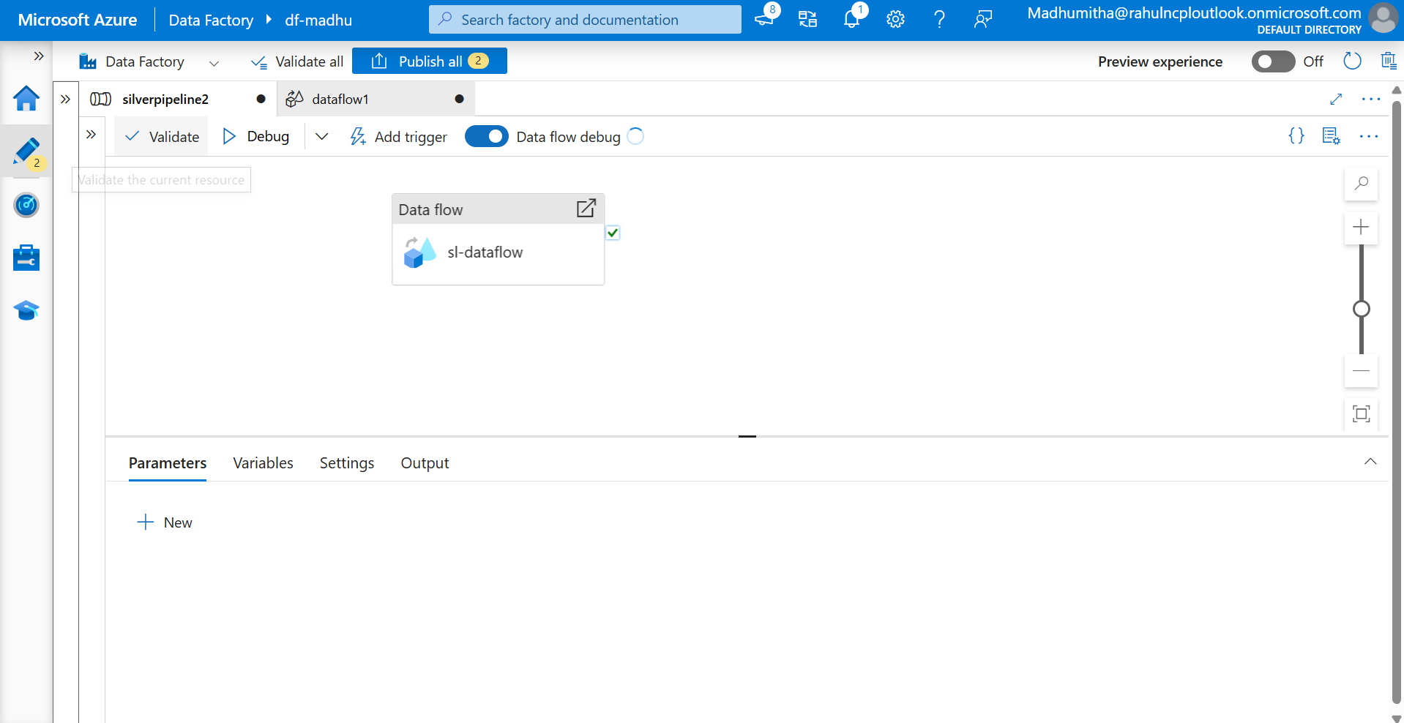

S2- Add the source in the dataflow and rename it as accountssource

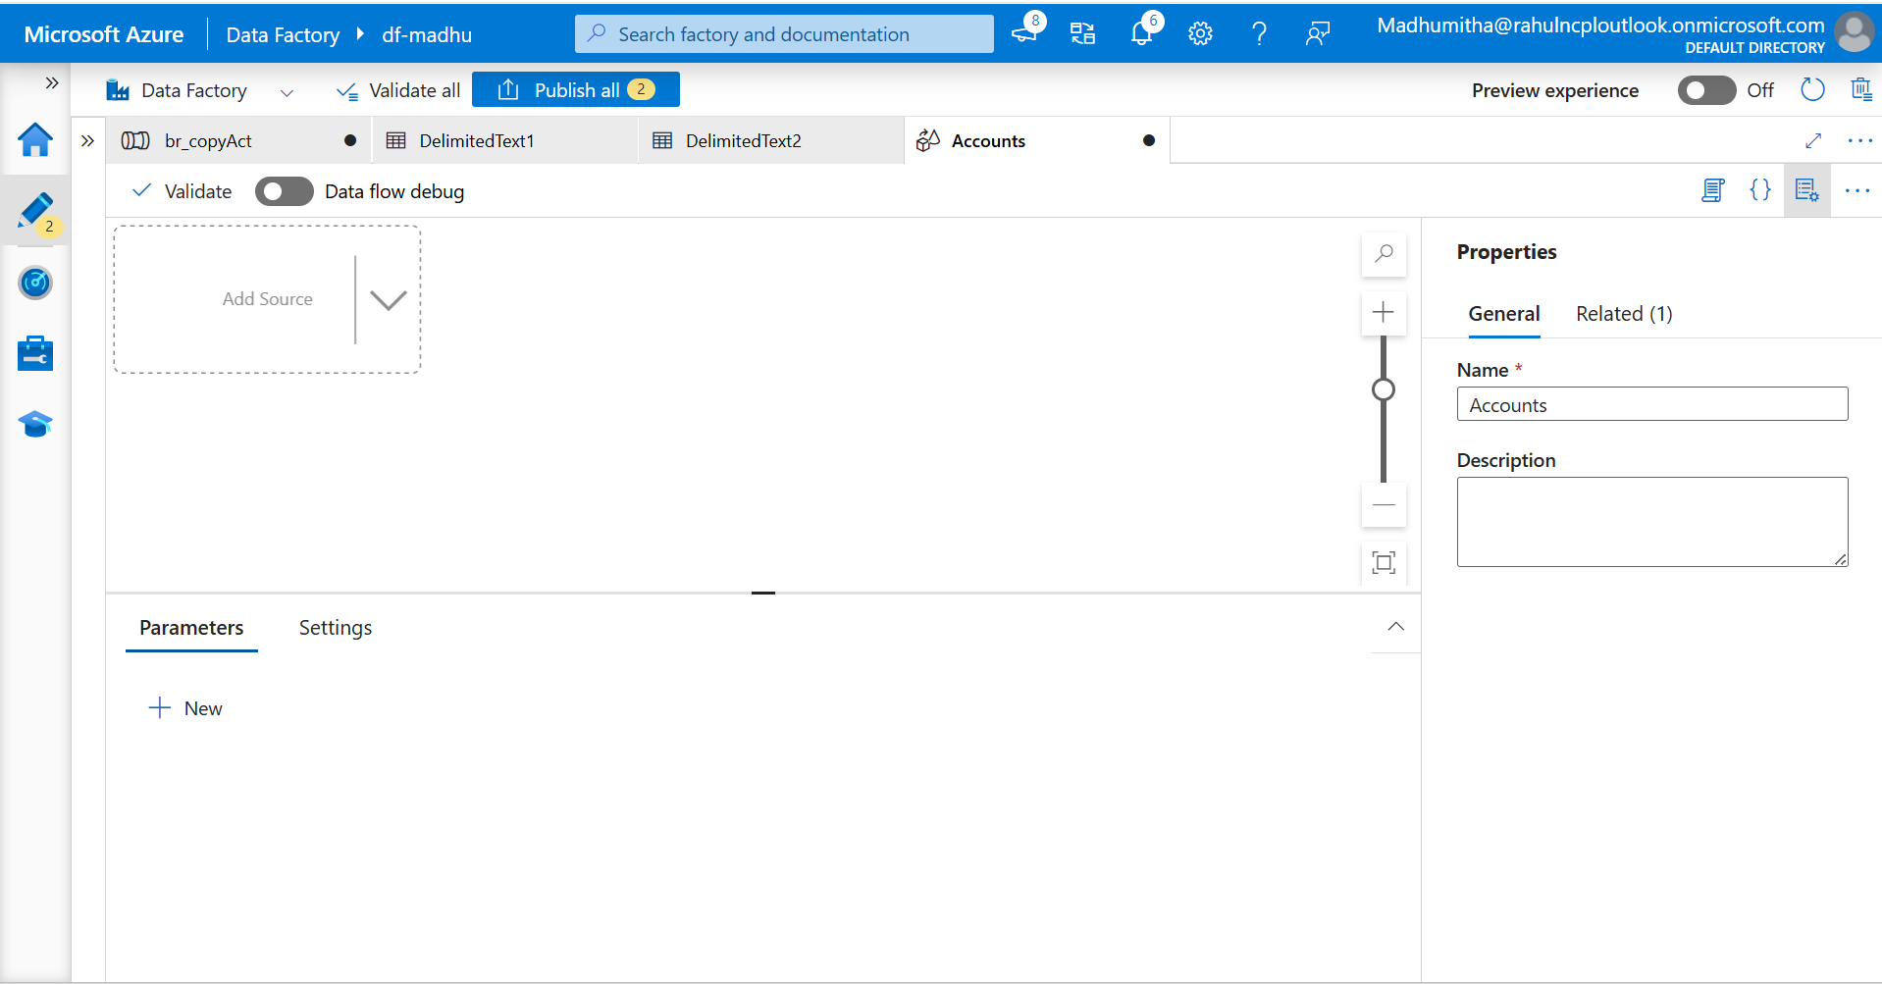

S2 – Rename accountssource as a source

S3- Select inline and delimited text from dataset type, choose adlsgen and test connection.

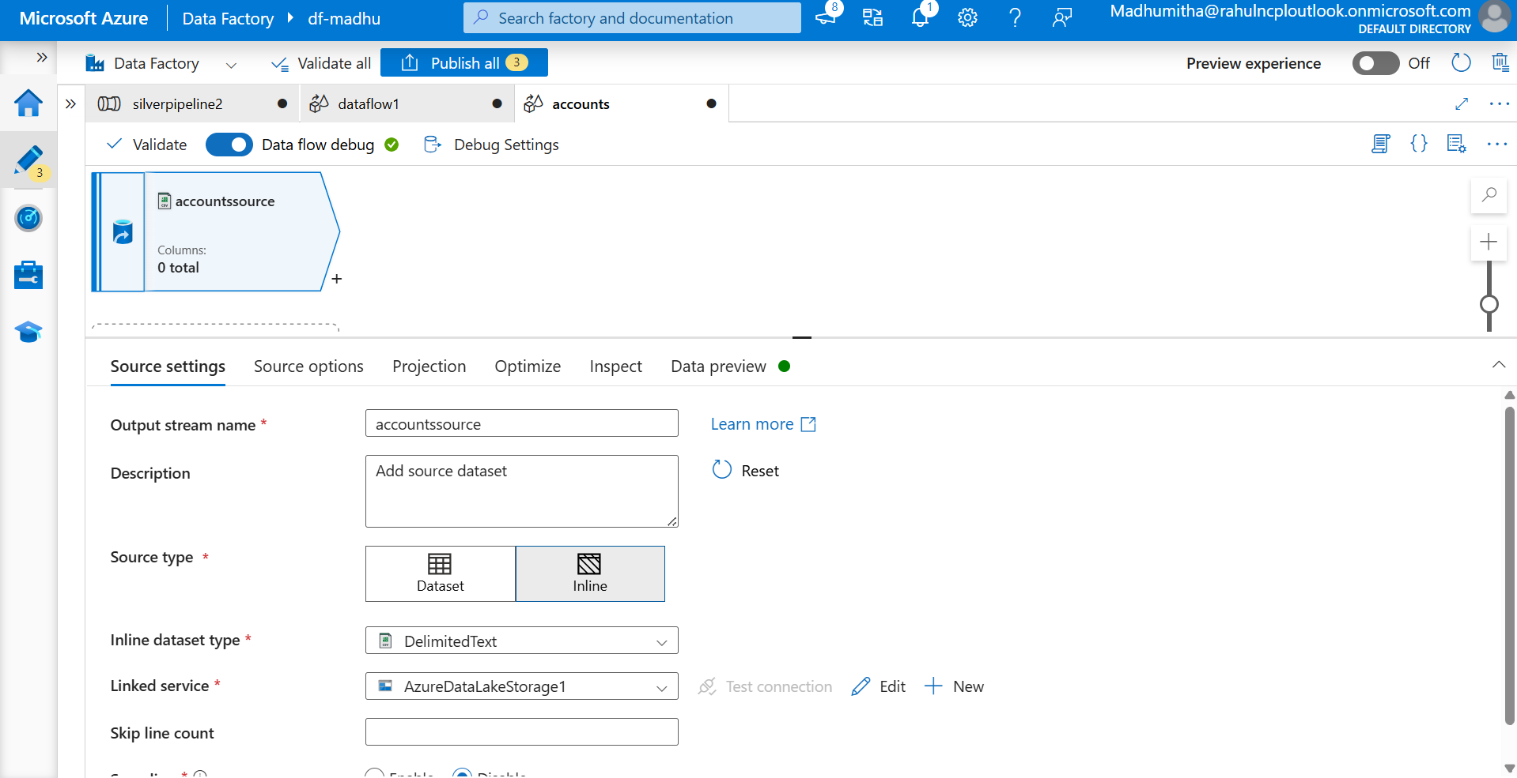

S3- Select the file path and file as accounts.csv

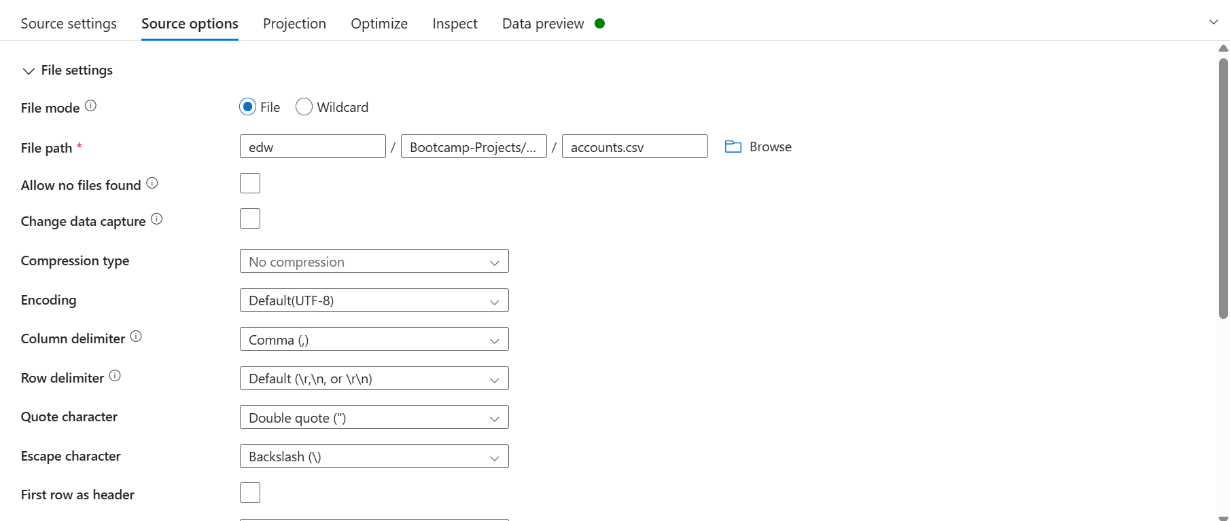

S4- Navigate to projection tab, import the schema

The Projection tab allows you to define, inspect, and modify the schema (columns and data types) of your incoming dataset before performing any transformations.

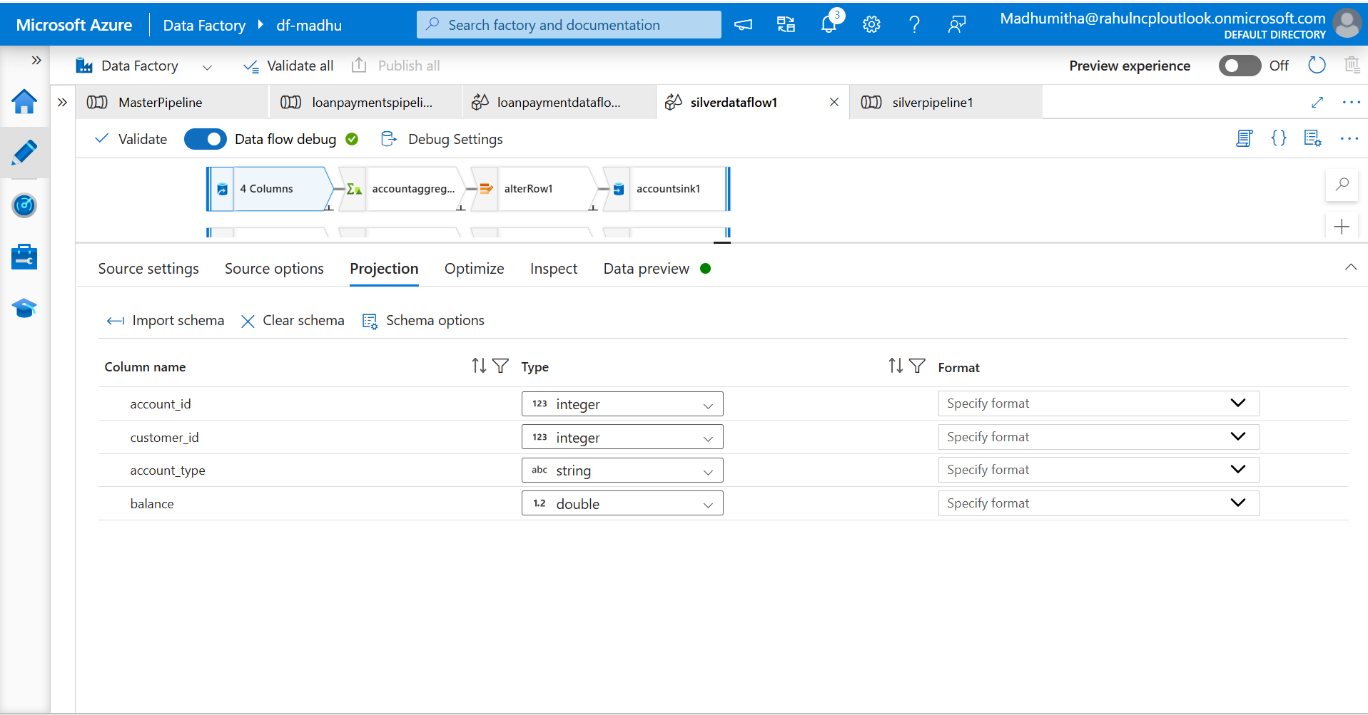

S5- Refresh the data preview to check the data.

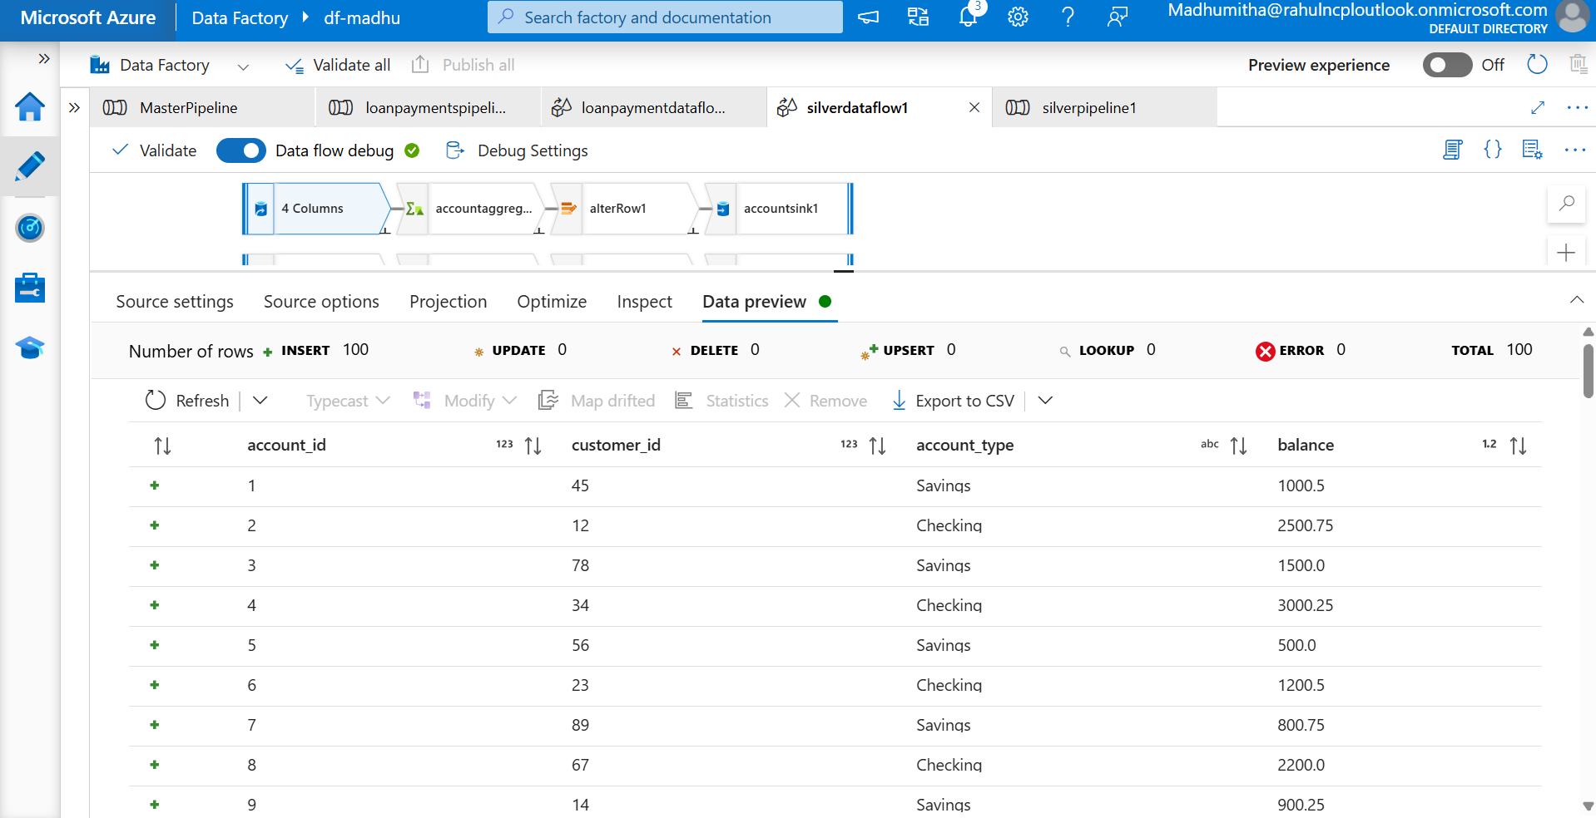

S6-Connect source with aggregate activity. In group by, add accountId.

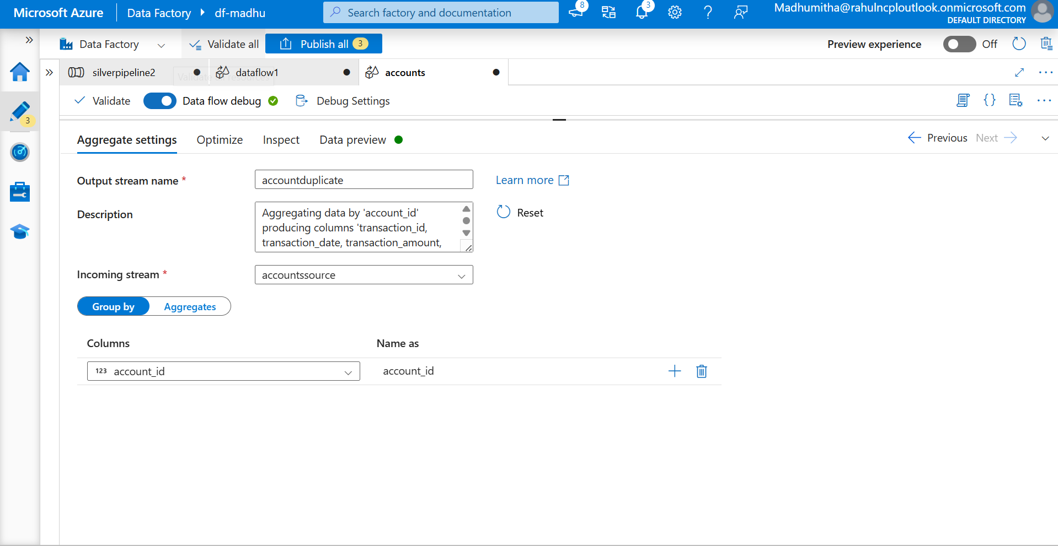

S7-In aggregate, add first($$) to map the columns for aggregation

$$ - It is a wildcard placeholder refer each matching column dynamically. First() aggregates function to each column selected by the condition.

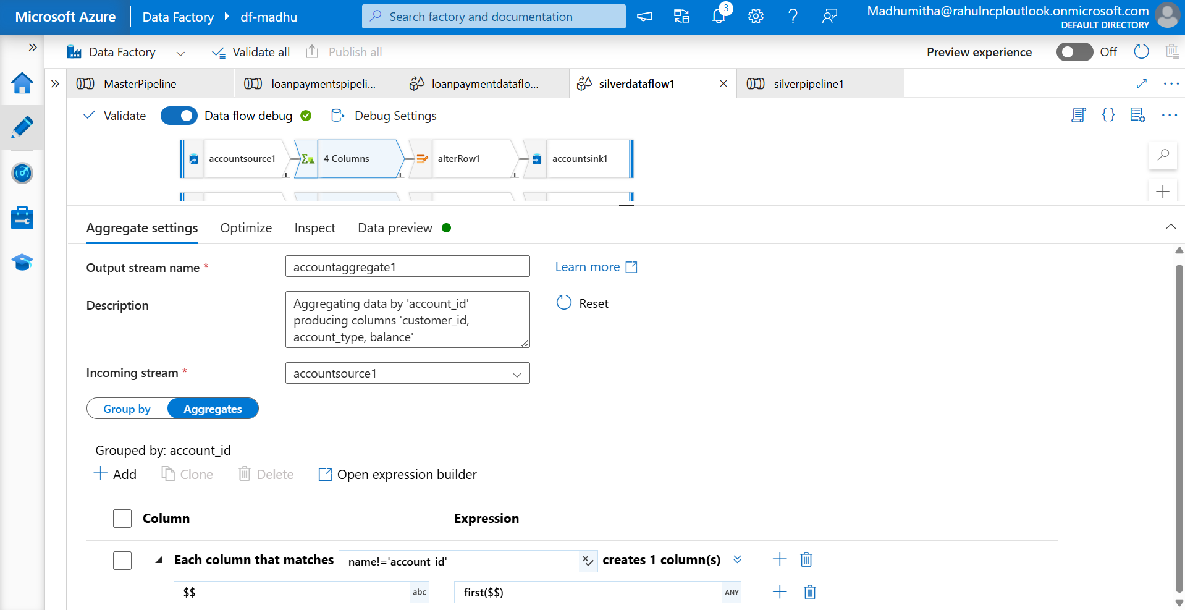

S8- Preview the data to check the outcome of the aggregation

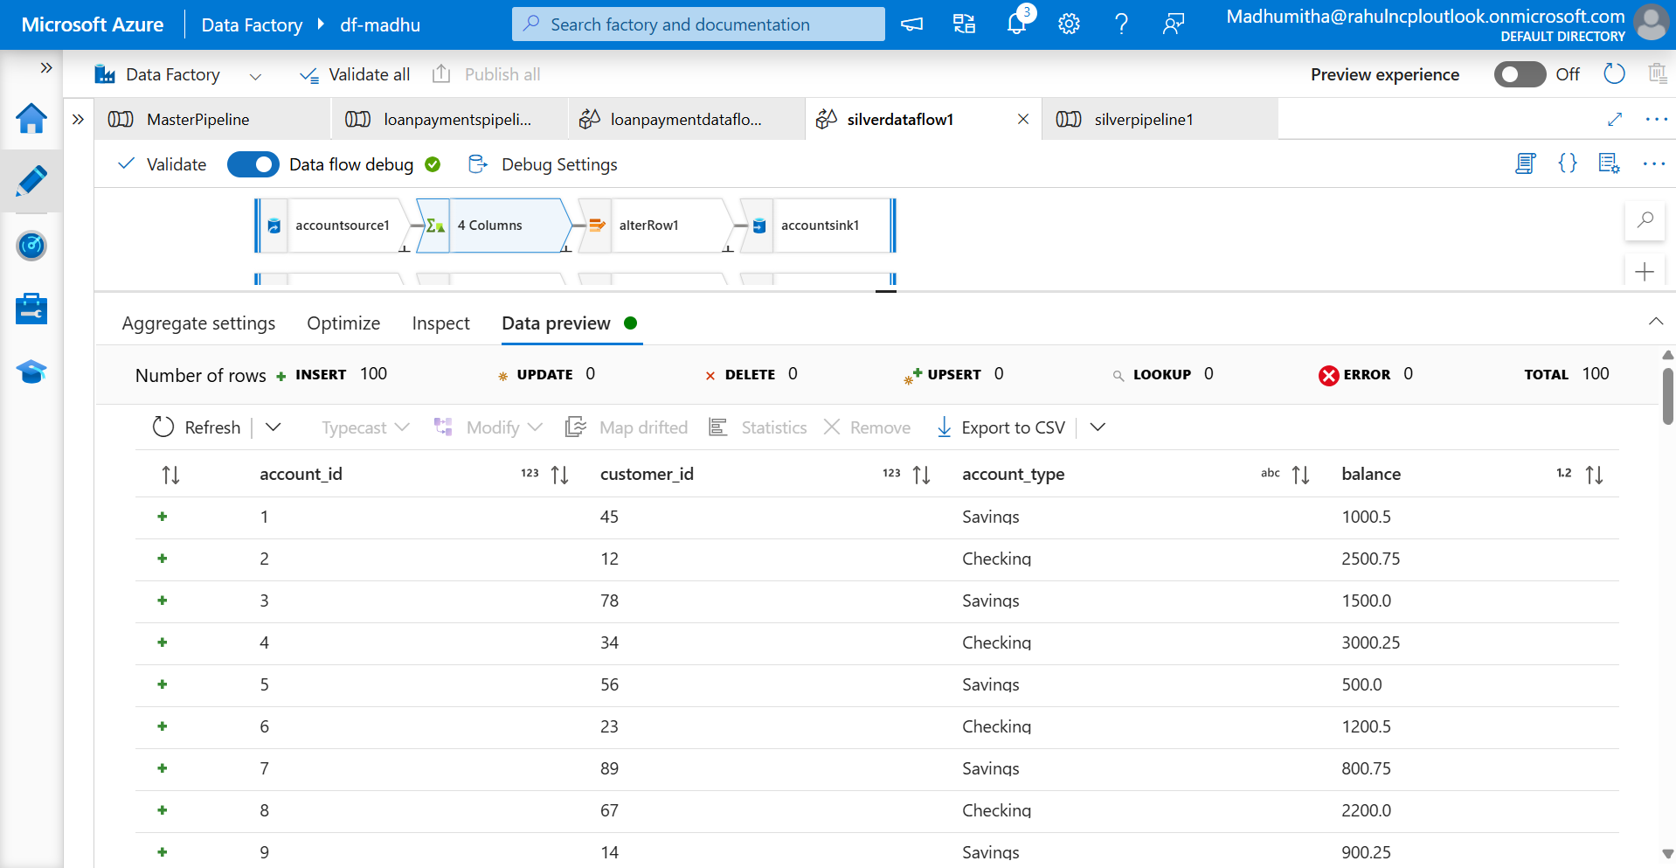

S9- Use alterRow, to set the policies in row. Here, set upsert if for every row

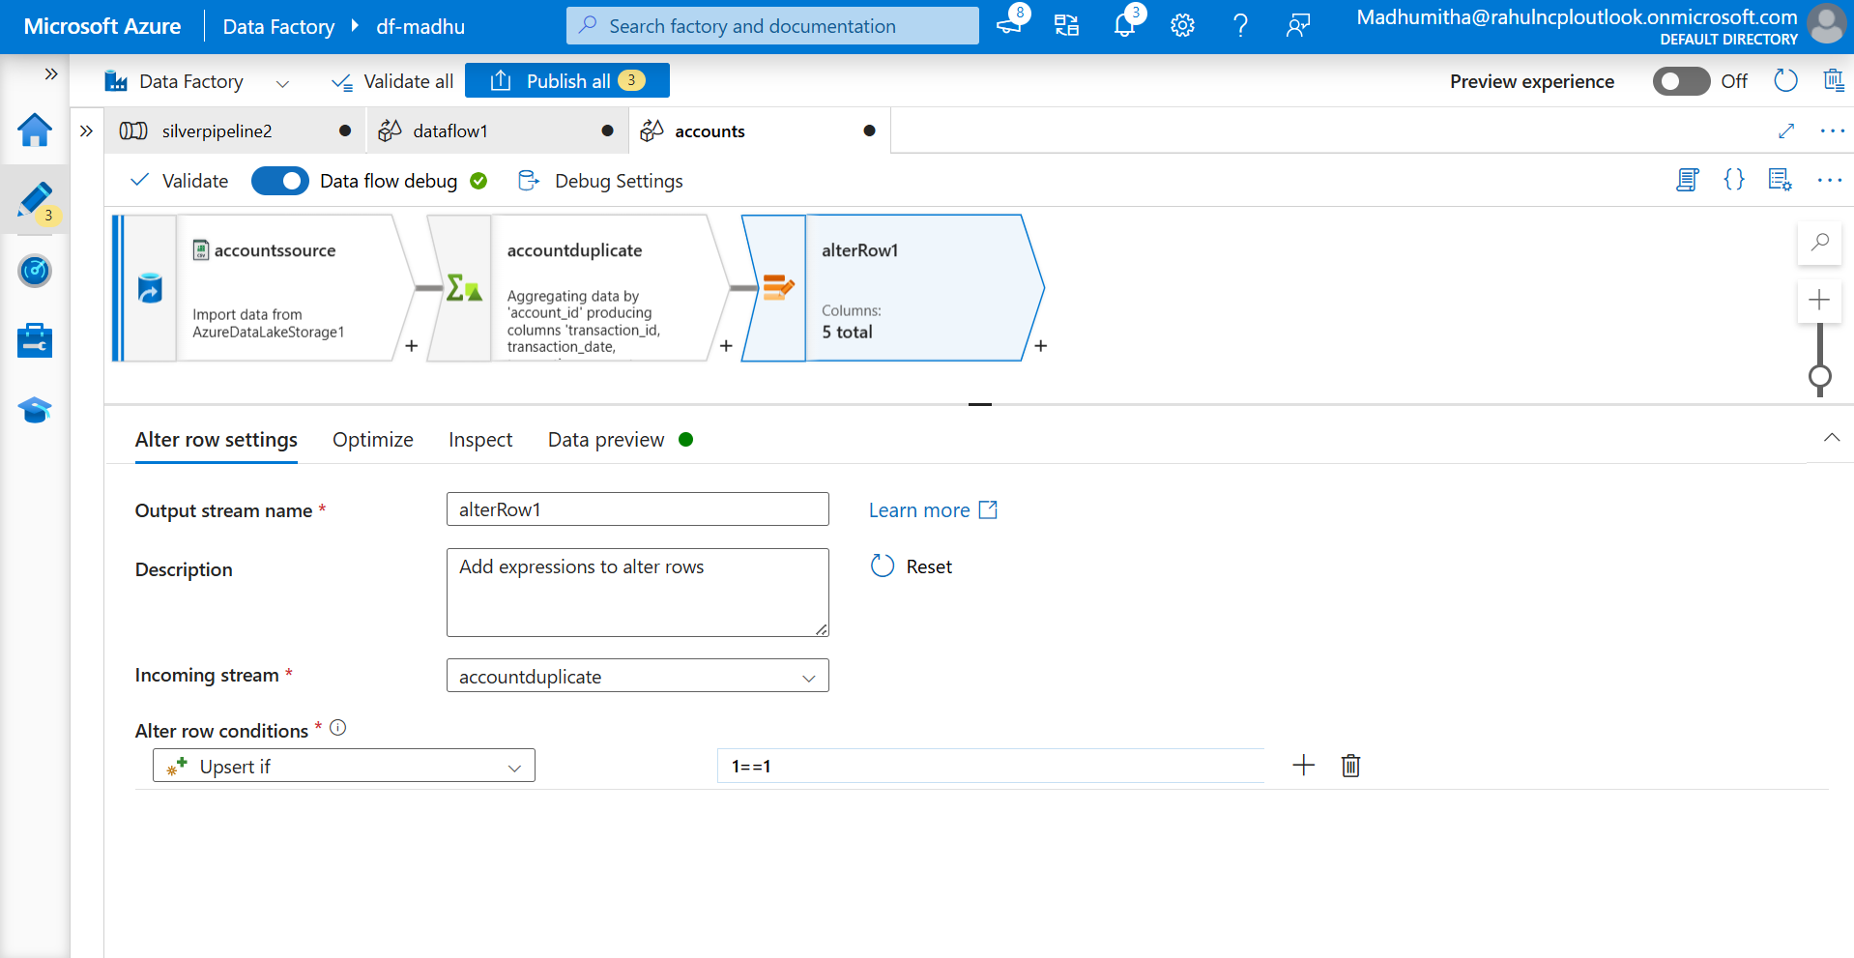

S10- Add sink, set the inline dataset and linked service.

AlterRow is used to control row-level operations and 1==1 will always evaluates to true.

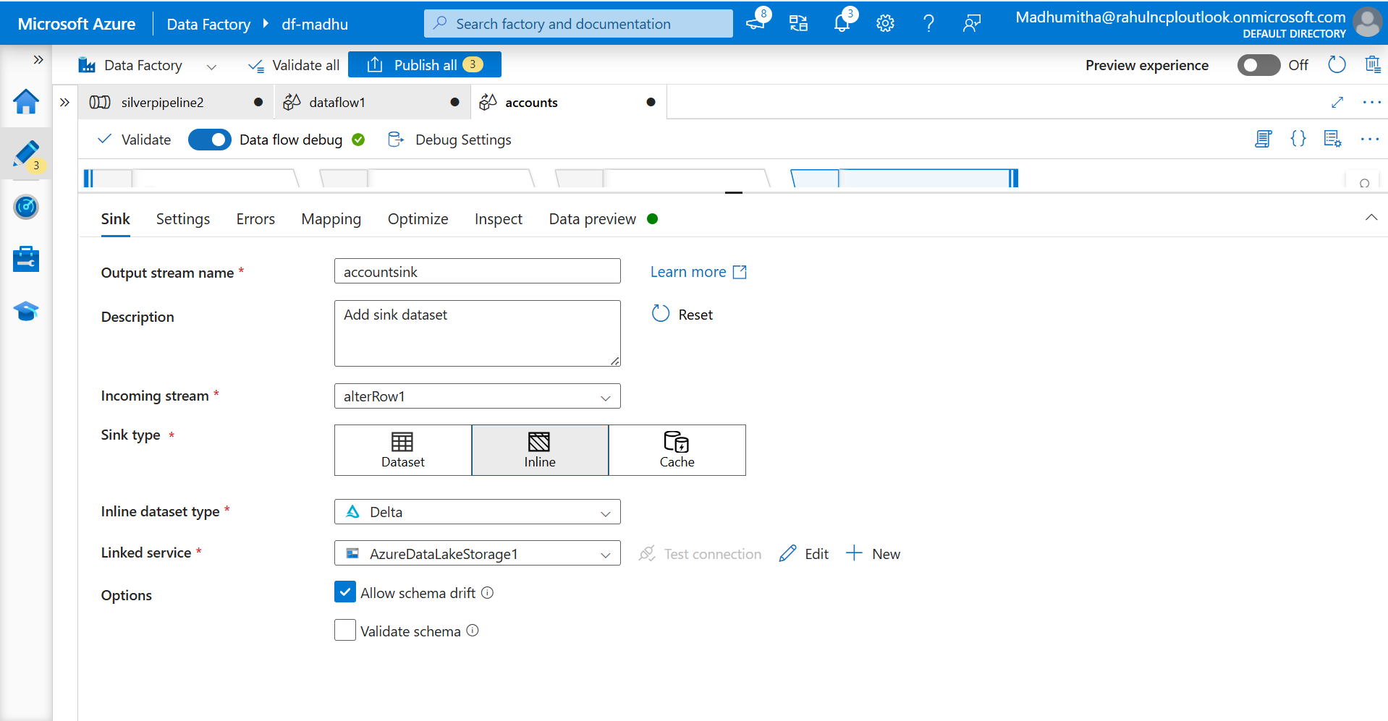

S11- Add the destination file path, enable the option upsert and add account_id in list columns

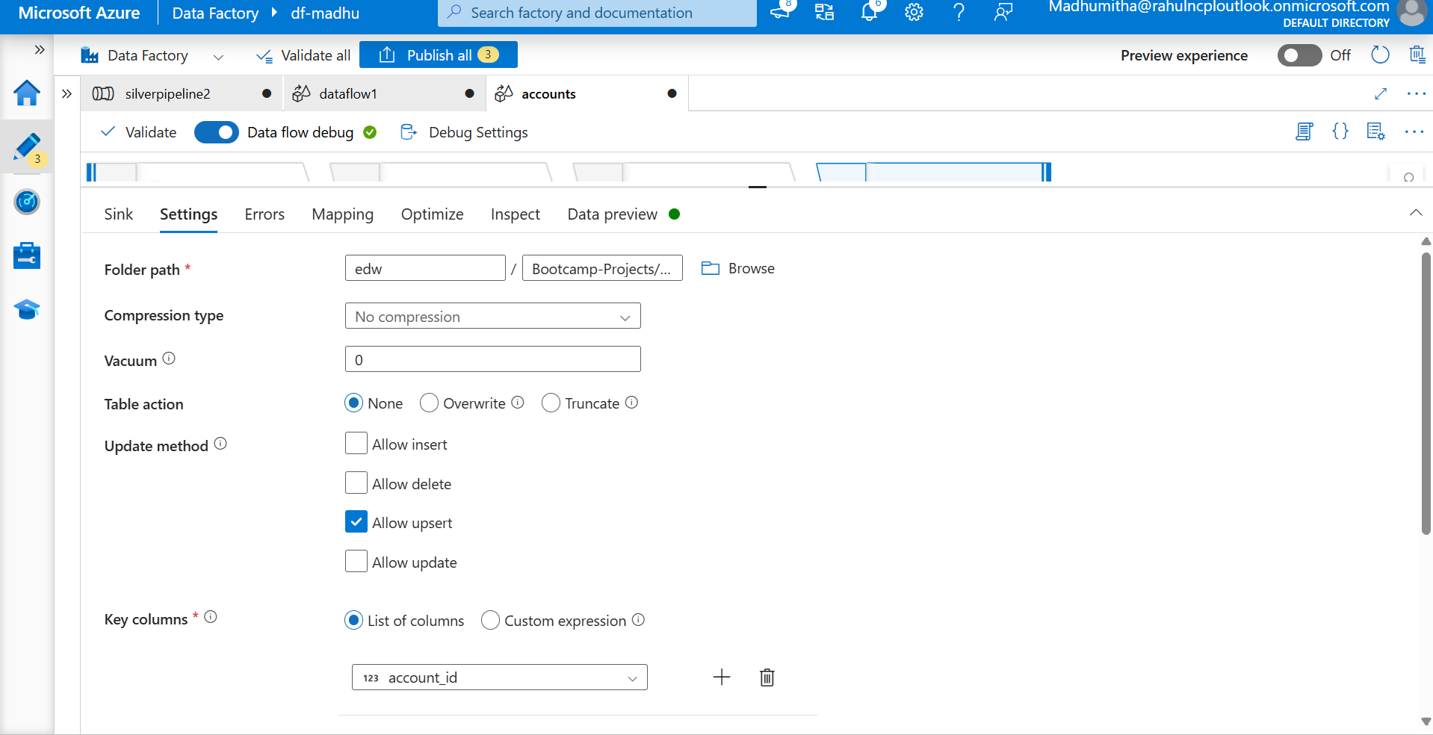

S12-Check the mapping by importing the schema

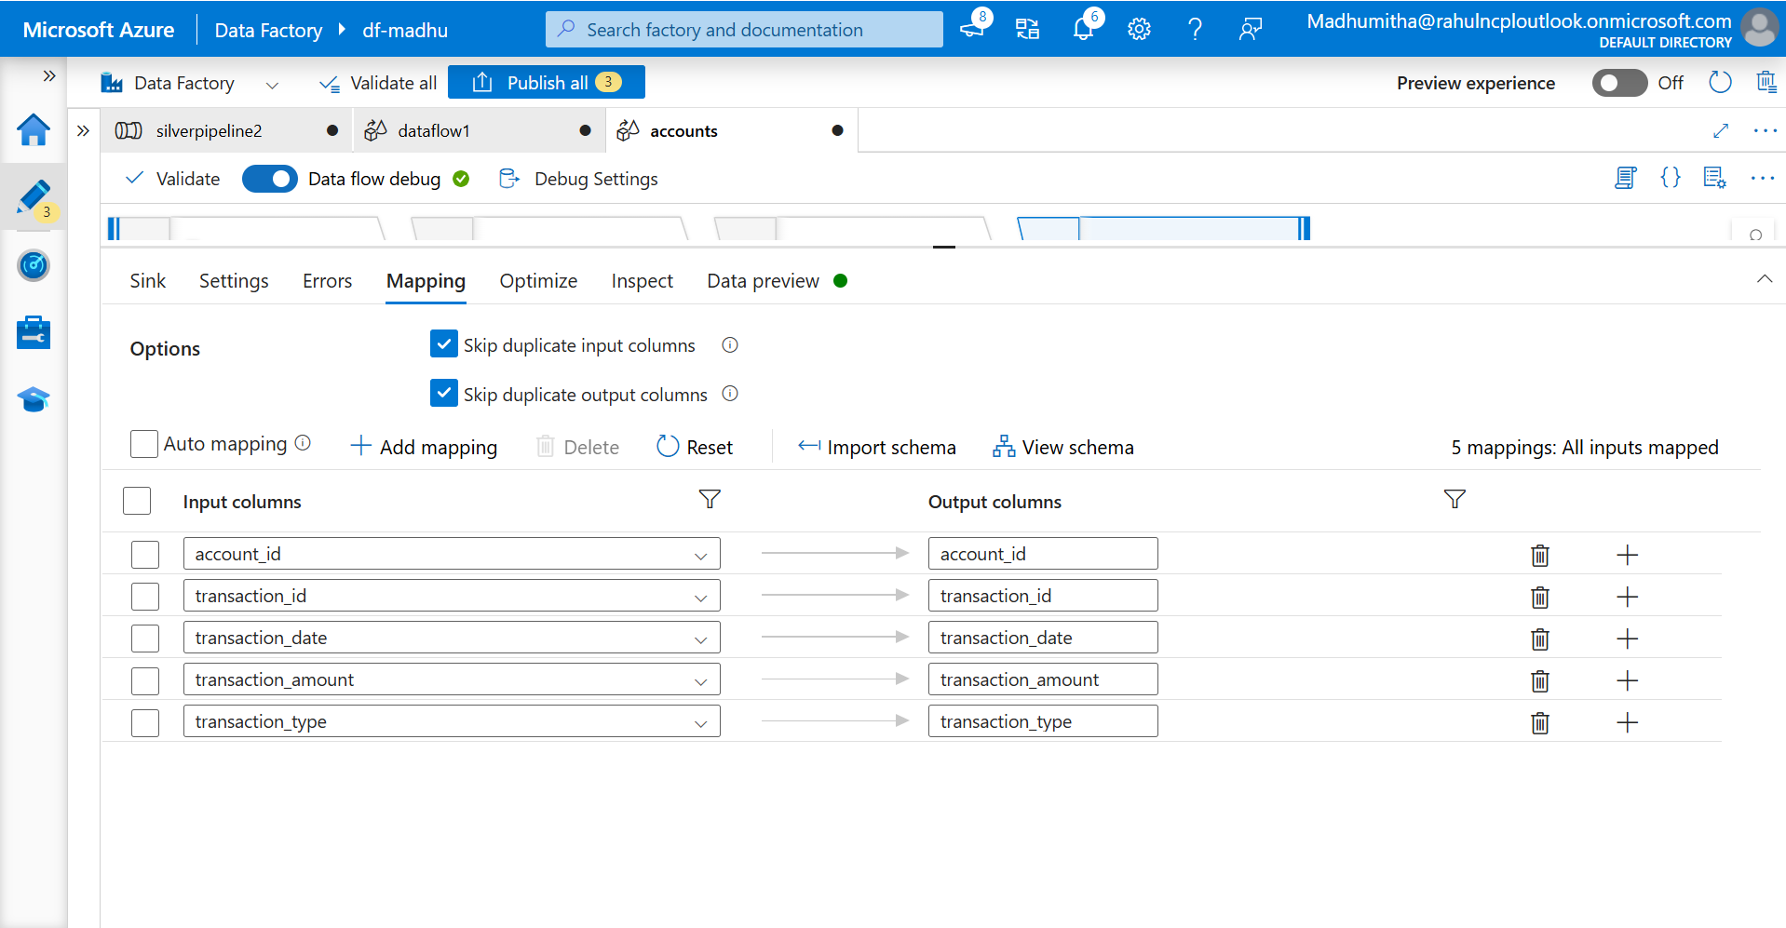

S13- Preview the data outcome of sink

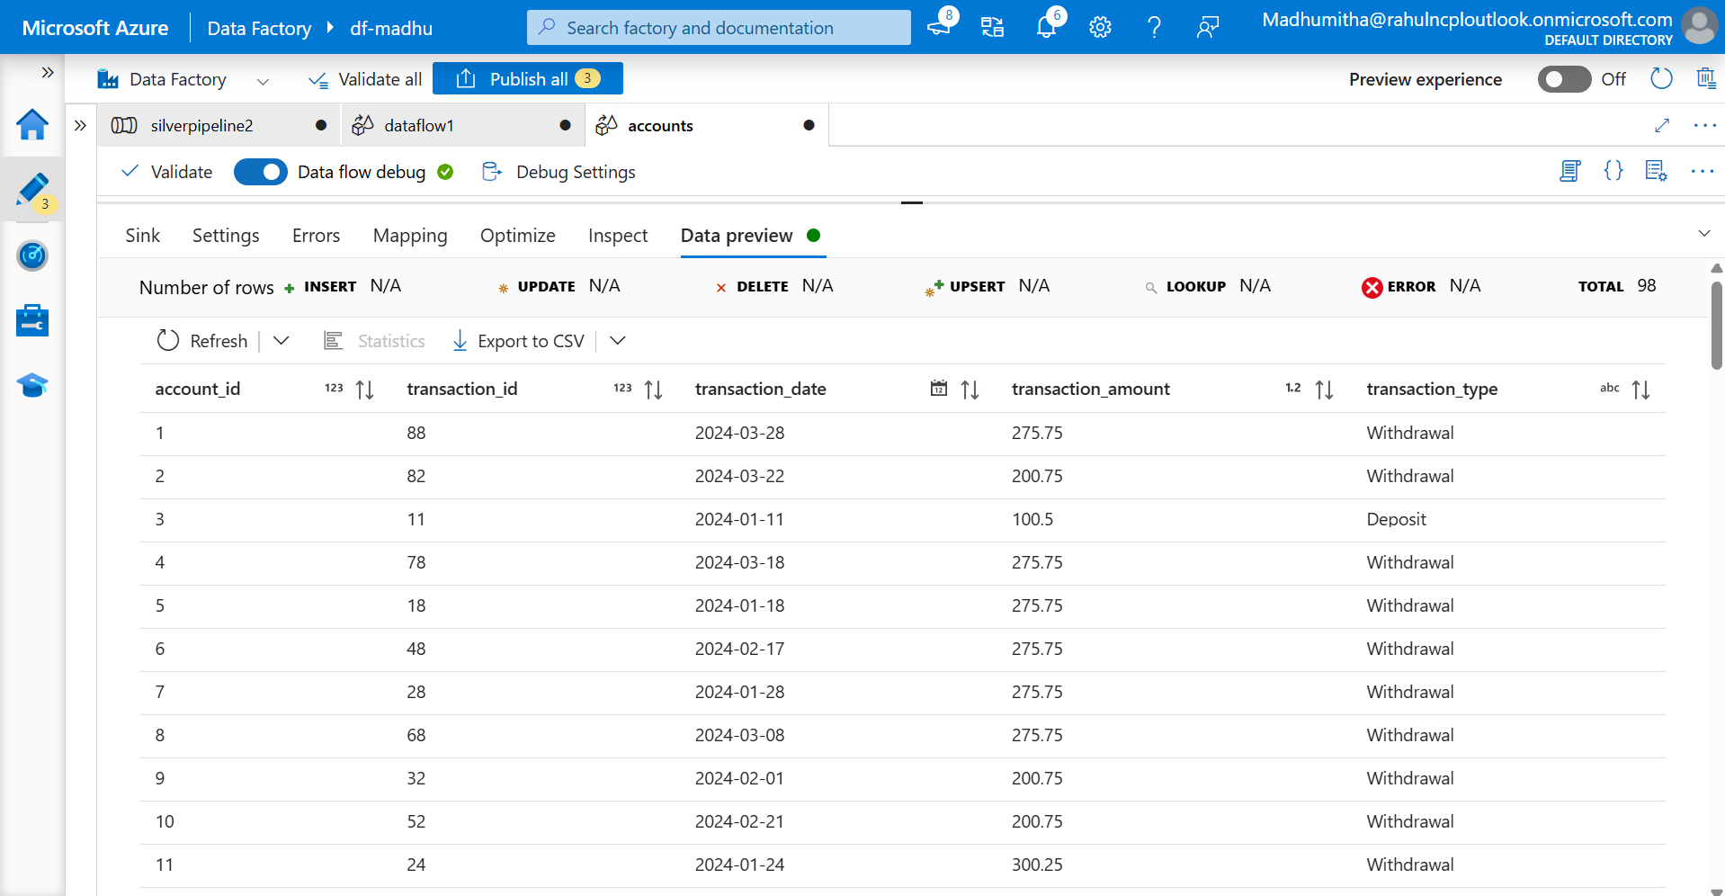

S14- Run the pipeline and check the ADLSGen2 for successful transformation of data

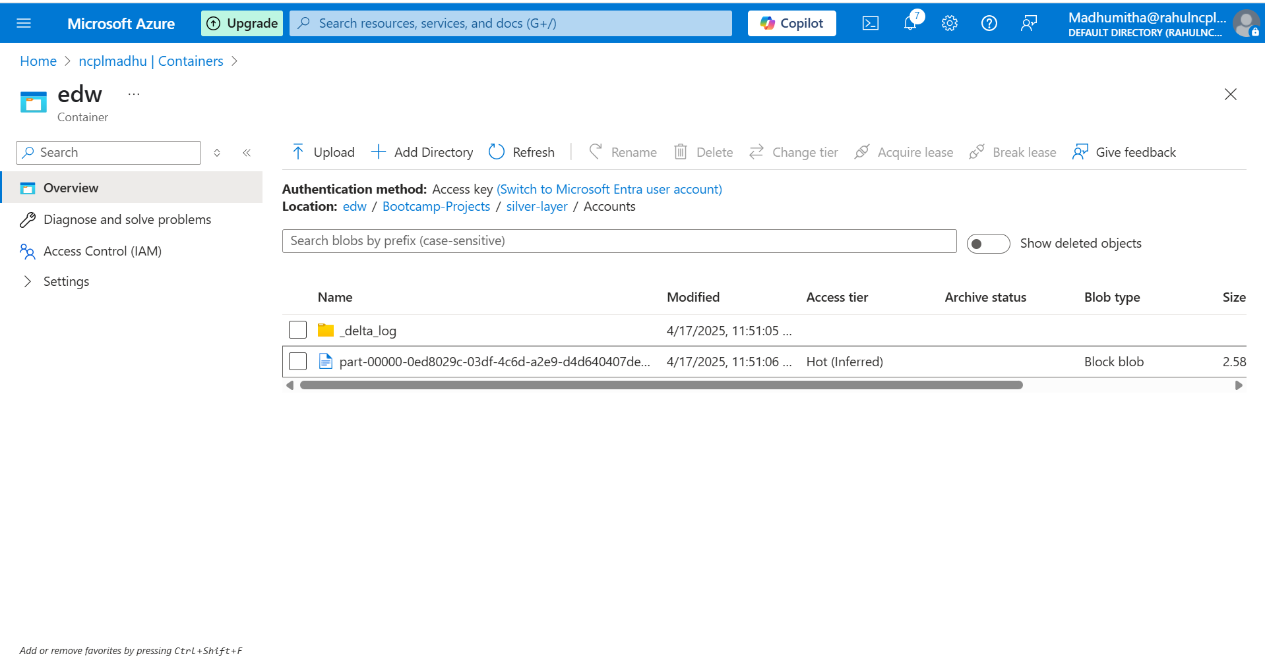

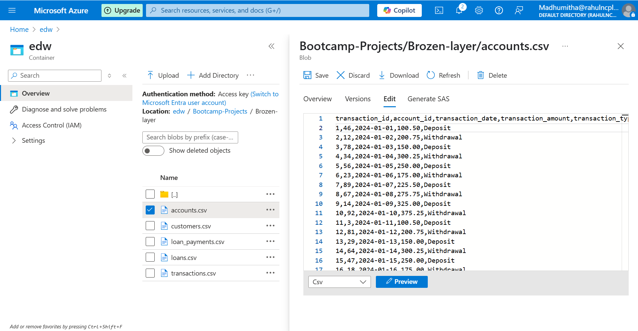

The same steps to be repeated for Customers, Loan datasets. For Loan payment and transaction, we need to use cast activity to handle date format.

S1 - In source, navigate to projection and change the payment_date into string

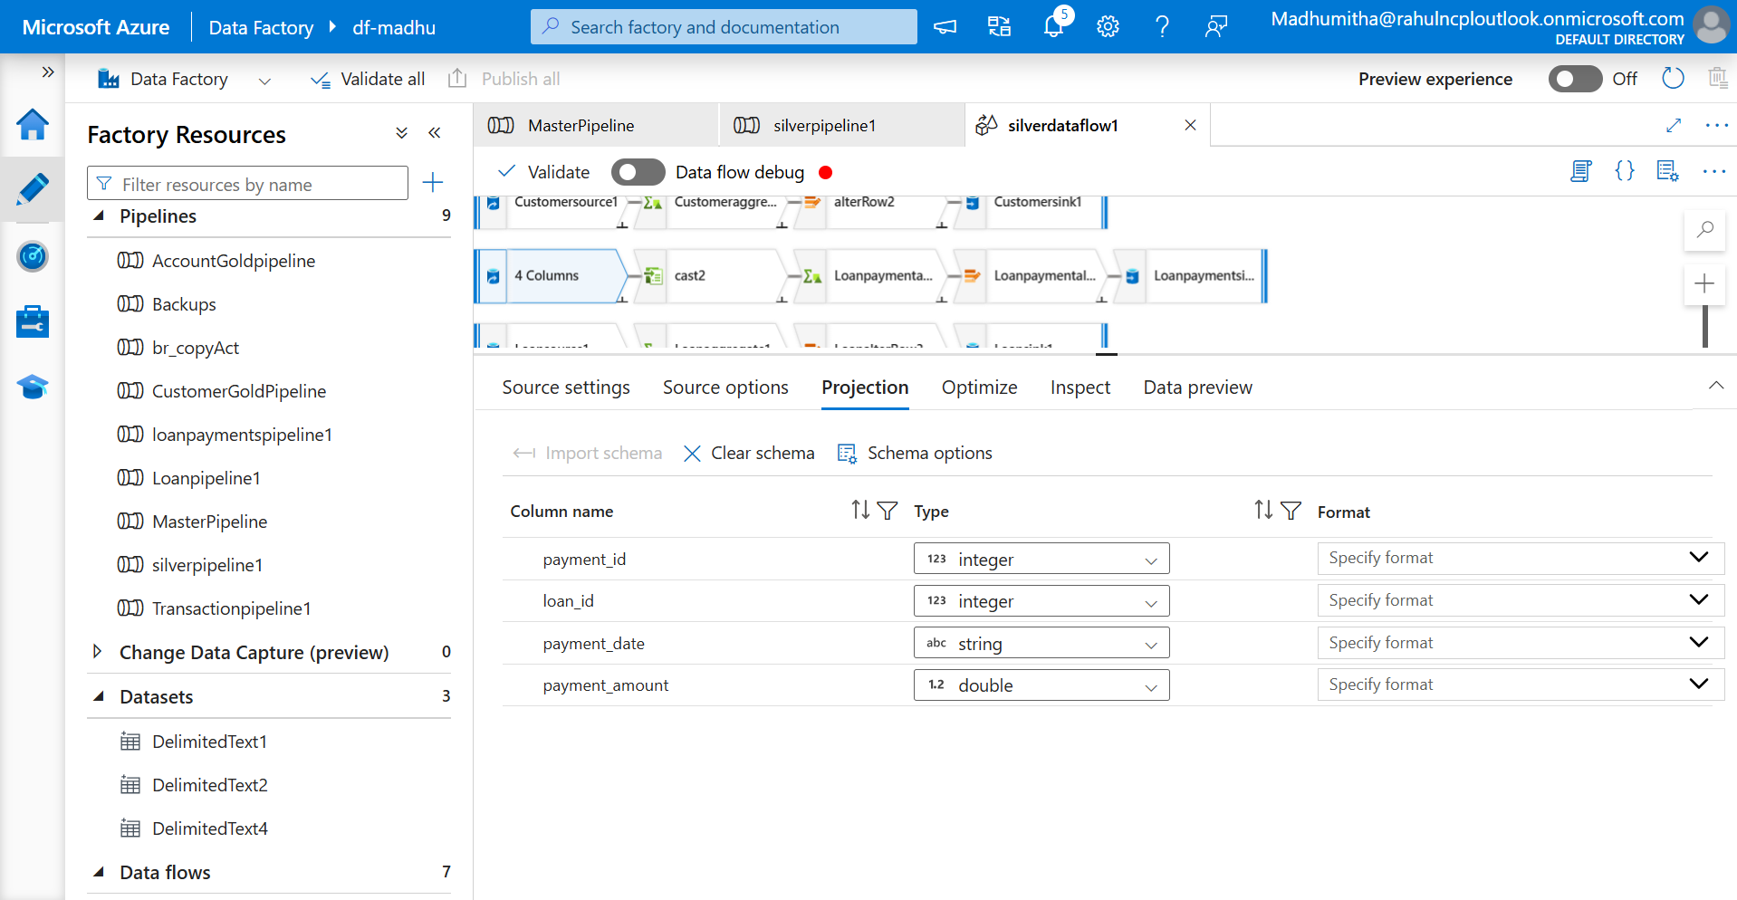

S2- Drag and drop the cast activity and connect it with source

Cast transformation will convert the datatype of one or more columns to one type or others.

S3- Specify the column name, change the datatype into date and choose the appropriate format.

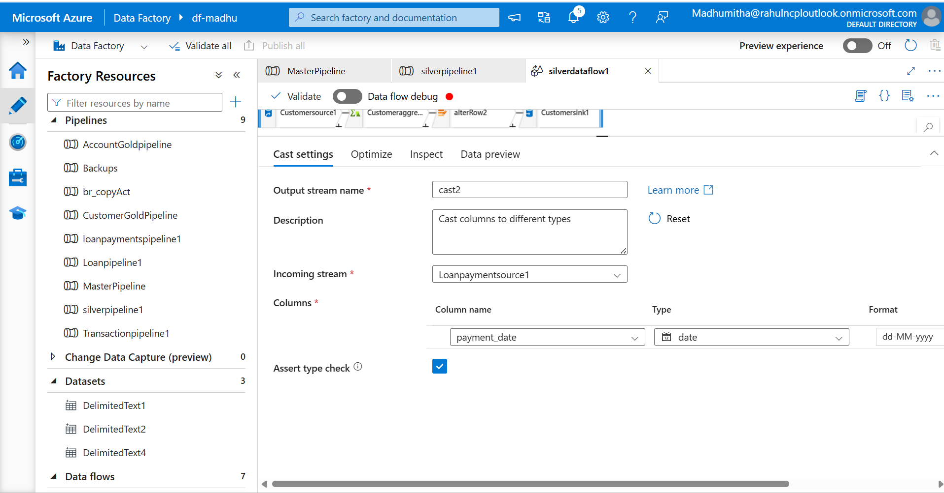

S3- Navigate to inspect, check the payment_date in date format

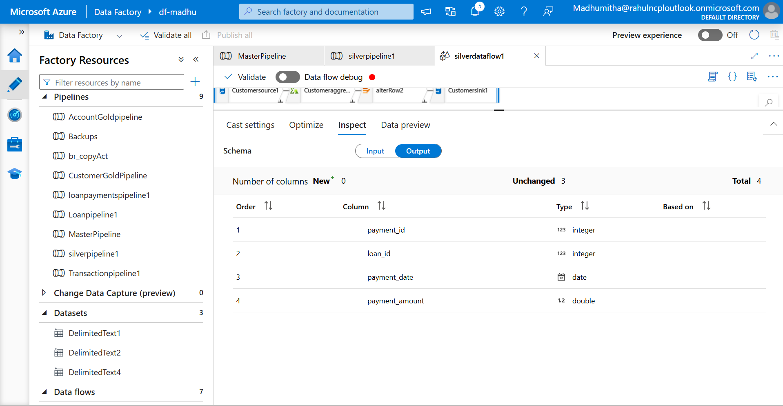

Continue with the next steps.

**GOLD LAYER**

**Dataflows using SCD type techniques**

We are going to use 3 SCD type1 flows and 2 SCD type 2 flows.

SCD type 1 -Create 3 tables(accounts, customer and loanpayments) with createby, createdate, updateby, updatedate and hashkey.

**Scripts**

Accounts

**create table accounts(account_id int,**

**customer_id int, account_type varchar(50),balance decimal(6,2),createdby varchar(100),updatedby varchar(100),**

**createddate datetime,updateddate datetime,hask_key bigint)**

**Customers**

**create table Customers(customer_id int,**

**firstname varchar(50),lastname varchar(50),address varchar(100),city varchar(30),**

**state varchar(30),zip varchar(20),createdby varchar(100),updatedby varchar(100),**

**createddate datetime,updateddate datetime,hask_key bigint)**

**Loanpayments**

**create table Loanpayments(paymentId int,**

**loanId int,paymentDate date,paymentAmount int,**

**createdby varchar(100),updatedby varchar(100),**

**createddate datetime,updateddate datetime,hash_key bigint)**

SCD type 2- Create 2 tables(Loans, Transactions) with createby, createdate, updateby, updatedate, isActive and hashkey

**create table Loan(loanId int,**

**CustomerId int,loanAmount decimal(7,2),interestRate decimal(2,1),**

**loanTerm int,createdby varchar(100),updatedby varchar(100),**

**createddate datetime,updateddate datetime,hash_key bigint,isActive int)**

**create table ltrans(transactionId int,**

**accountId int,transactionDate date,transactionAmount decimal(6,2),**

**transactionType varchar(50),createdby varchar(100),updatedby varchar(100),**

**createddate datetime,updateddate datetime,hash_key bigint,isActive int)**

Navigate to ADF, create 5 pipelines for each dataflow and build the process

**Accounts**

Source Activity

The source activity will tell the pipeline where to read data from and how that data should be interpreted before any transformation happens.

S1- Select the source type as inline, delta in inline dataset type and linked service as Azure data lake gen2

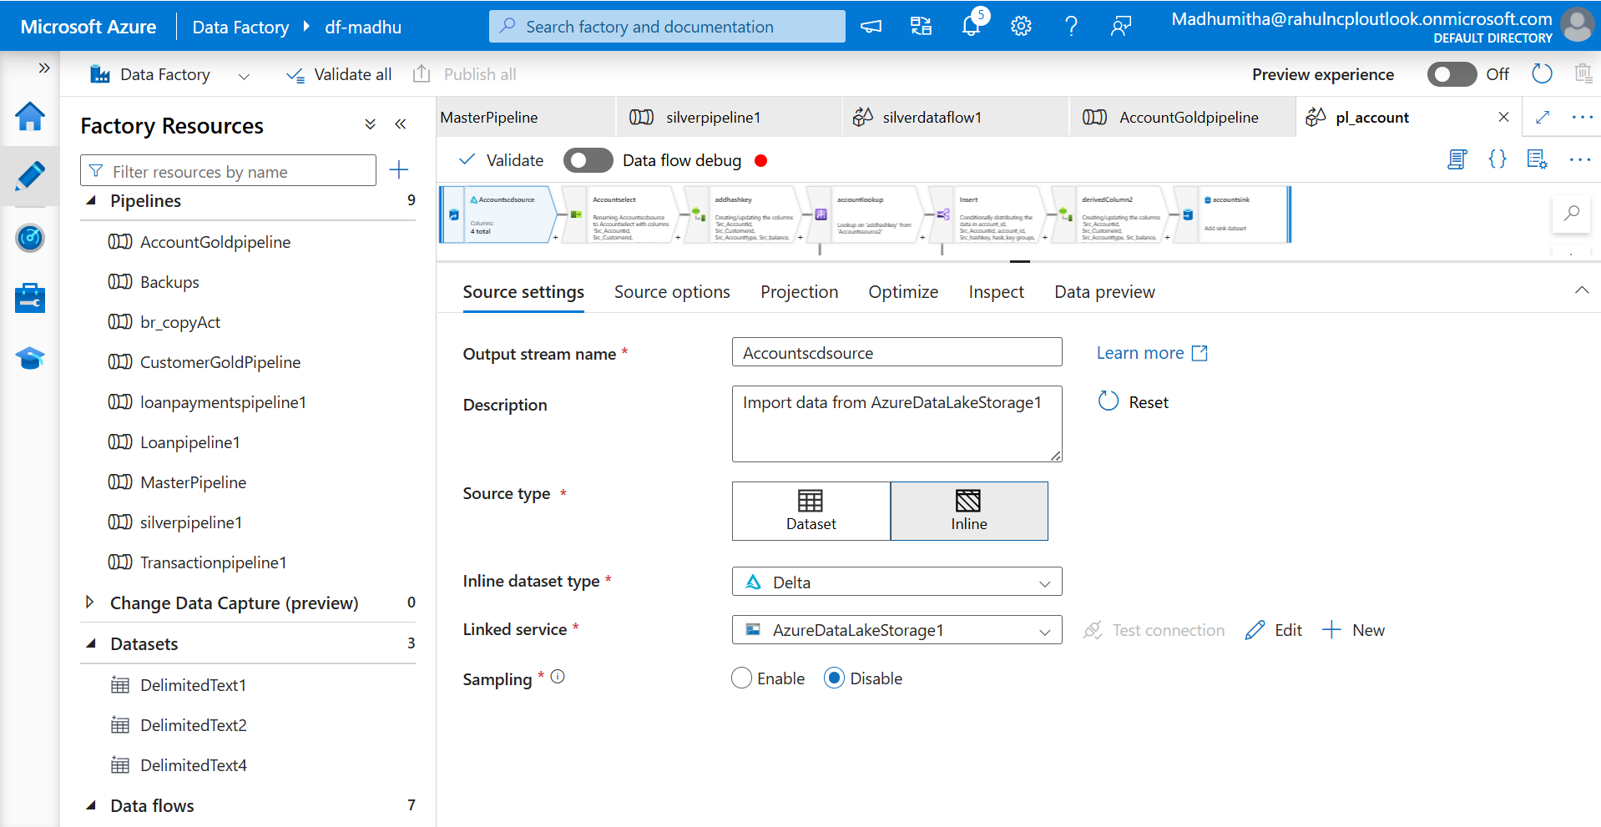

**S2-** Add the folder path and navigate to projection and data preview to check the preview of the data.

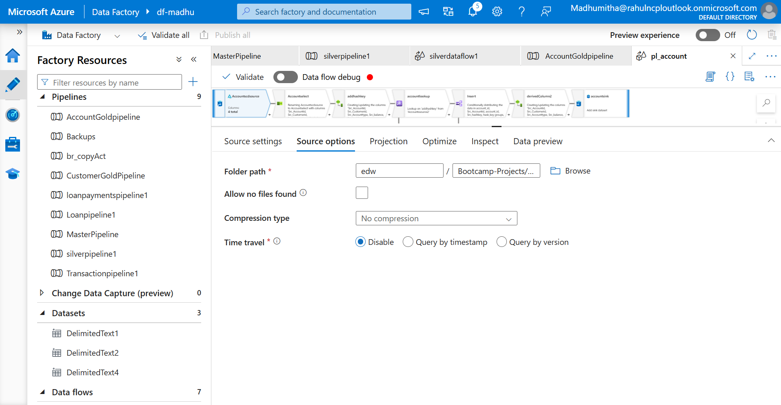

Select activity

S3 - Select activity is used to rename, drop or reorder columns in your dataset.

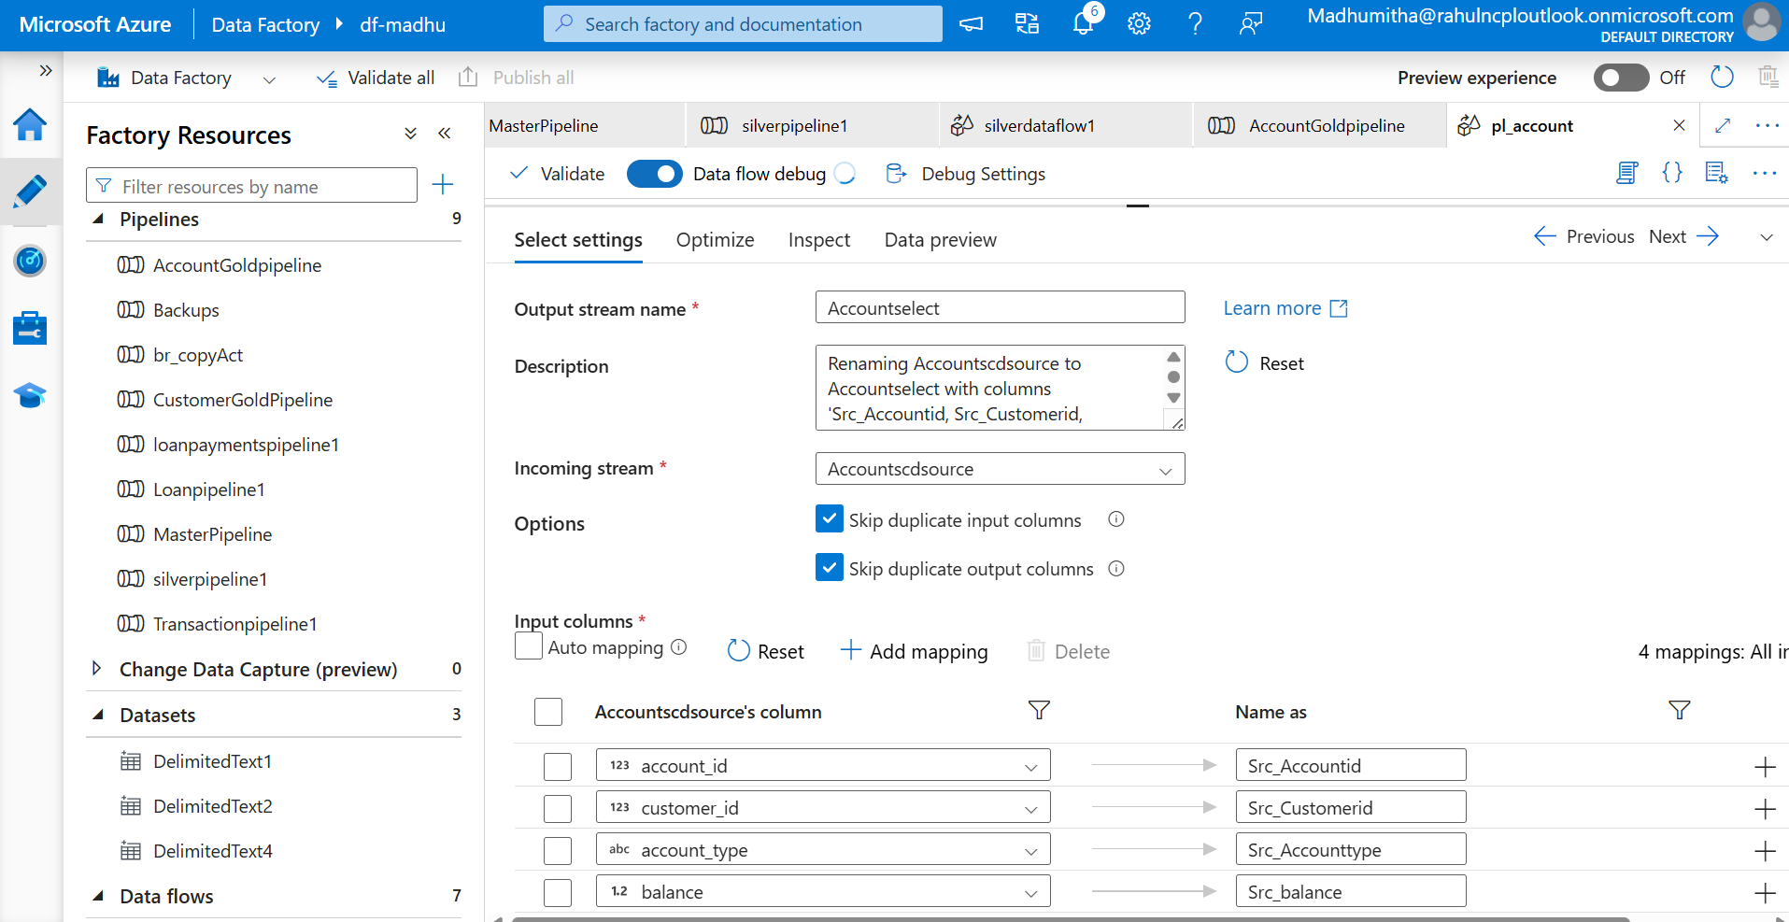

Derived activity

S4 -The derived transformation allows you to create new columns by applying expressions to existing columns, modify the values in existing columns.

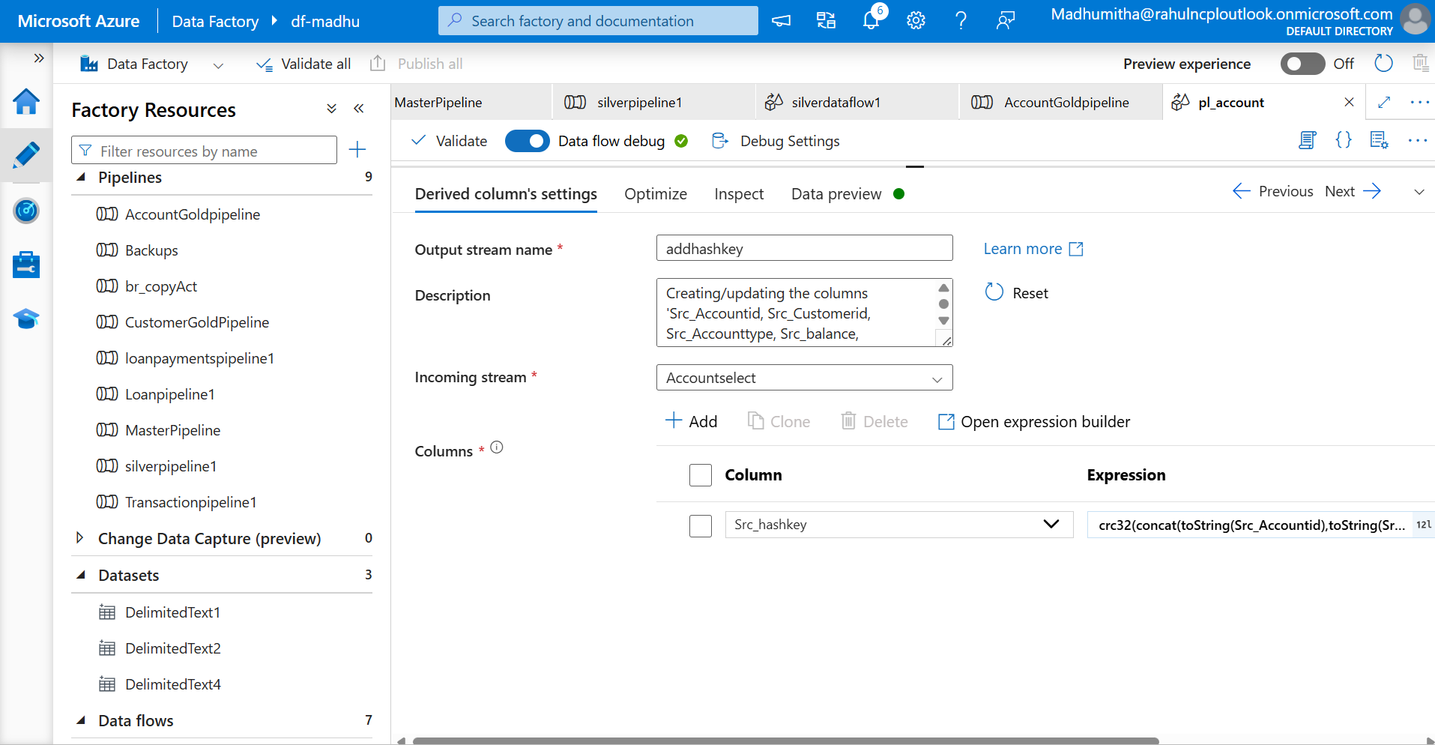

To generate hashkey, use crc32 function to generate numeric hashkey.

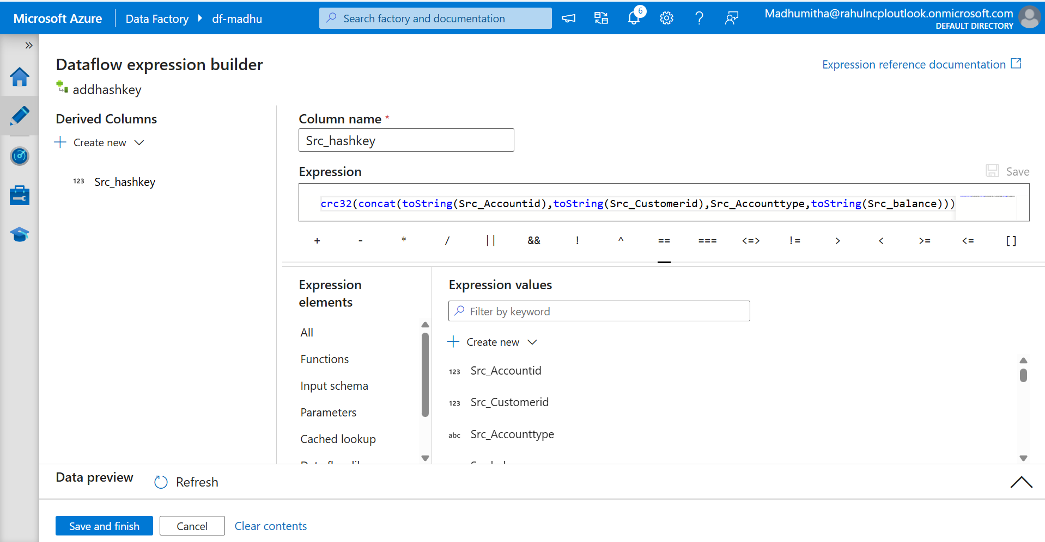

**Source activity**

**S5 –** Select the SQL database as source and select account_id and hashkey from accounts table and preview the data in datapreview.

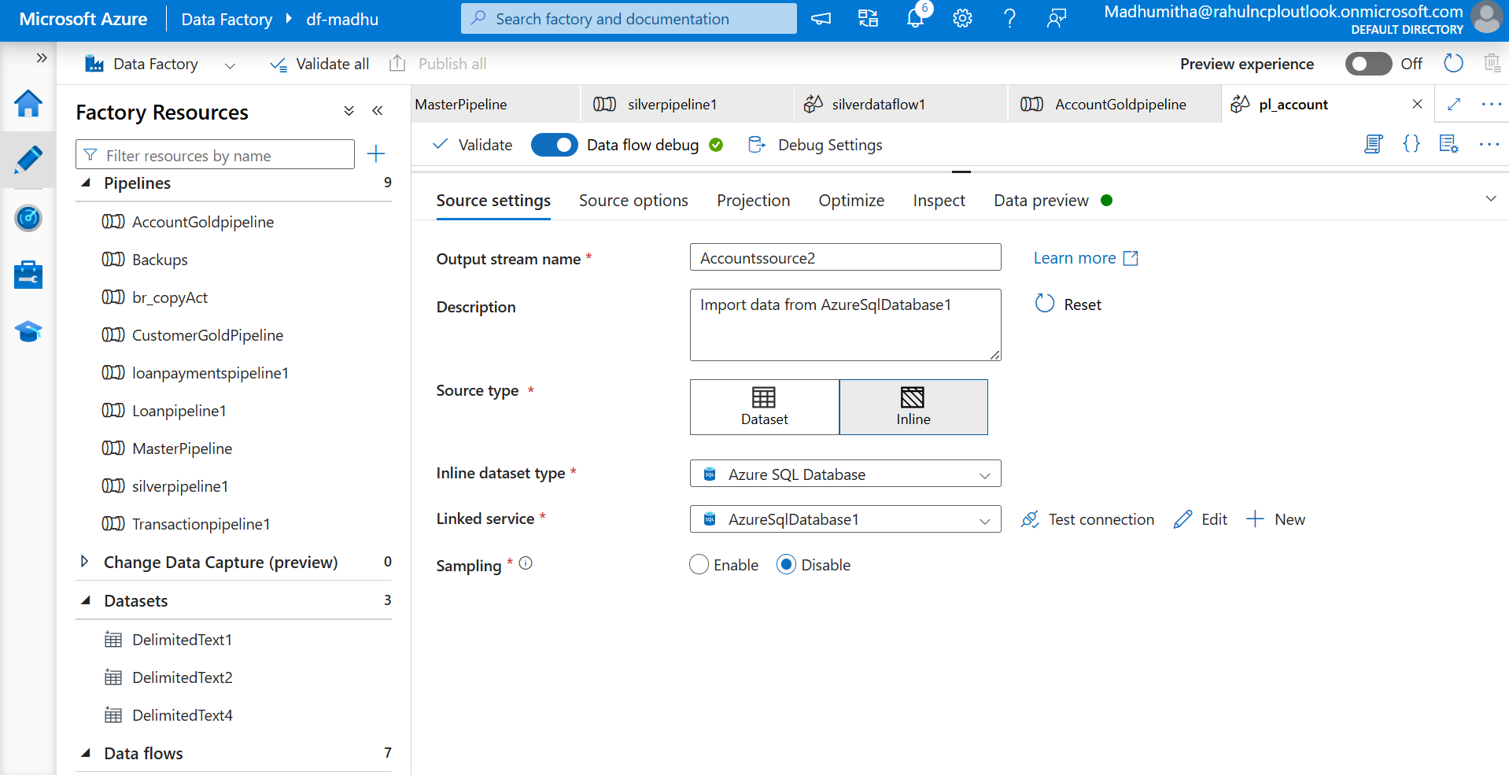

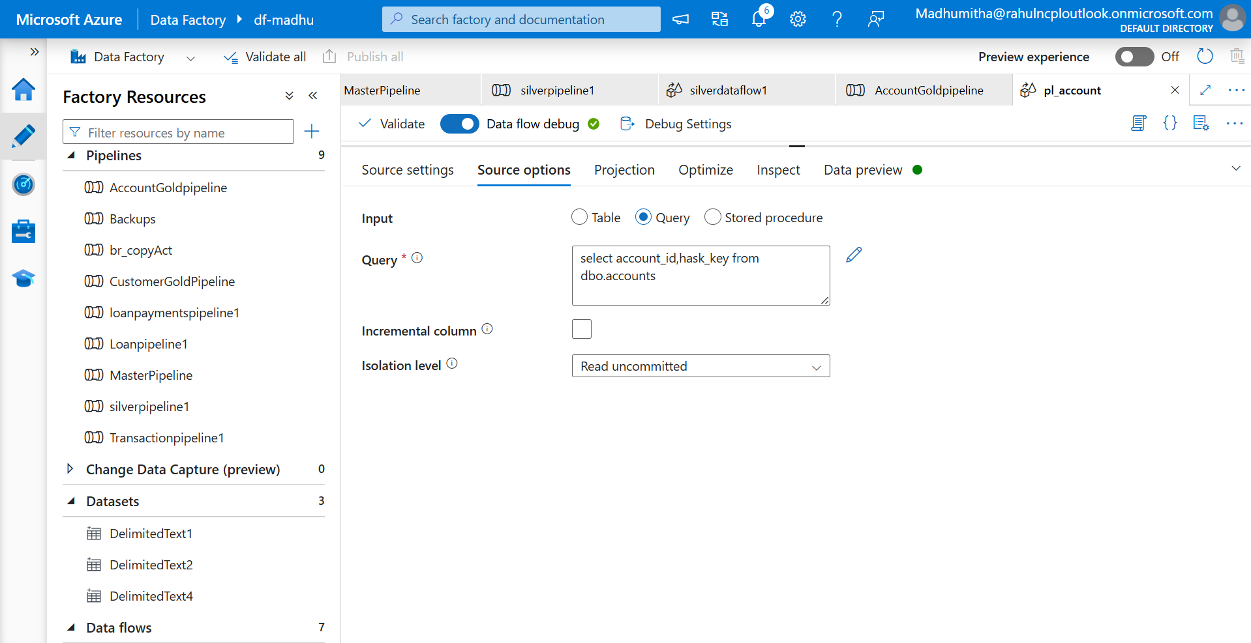

**Lookup activity**

It is used to retrieve data from a data source. Here we use look up activity as a left join.

S6- Give condition as src_Accountid==account_id and preview the data in DataPreview tab.

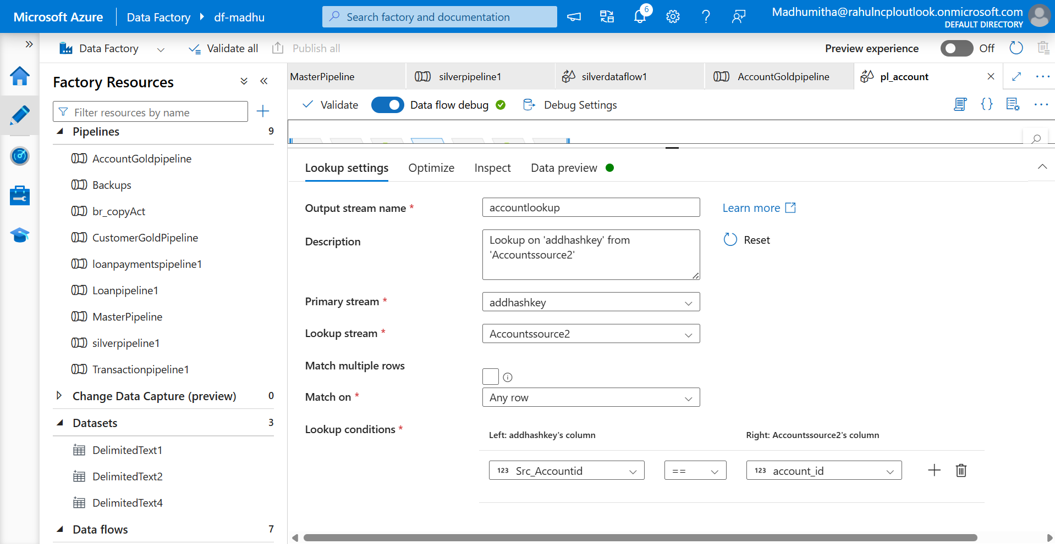

**Conditional Split**

Allows you to evaluate expressions and send rows down different paths depending on whether conditions are met.

S7- Add insert and update as split condition

S8-Insert option will get executed when accound_id is NULL.

Update option will get executed when Src_Accountid==account_id&&Src_hashkey!=hask_key

Preview the data in data preview tab.

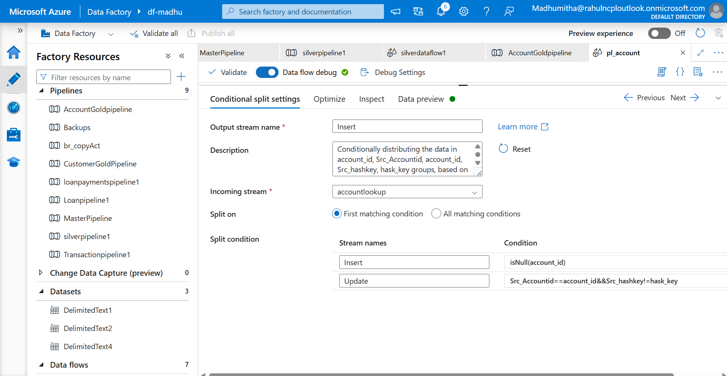

Insert->Derived activity

S9 – Add the expressions for createby,Updateby,Createdate,updatedate columns.

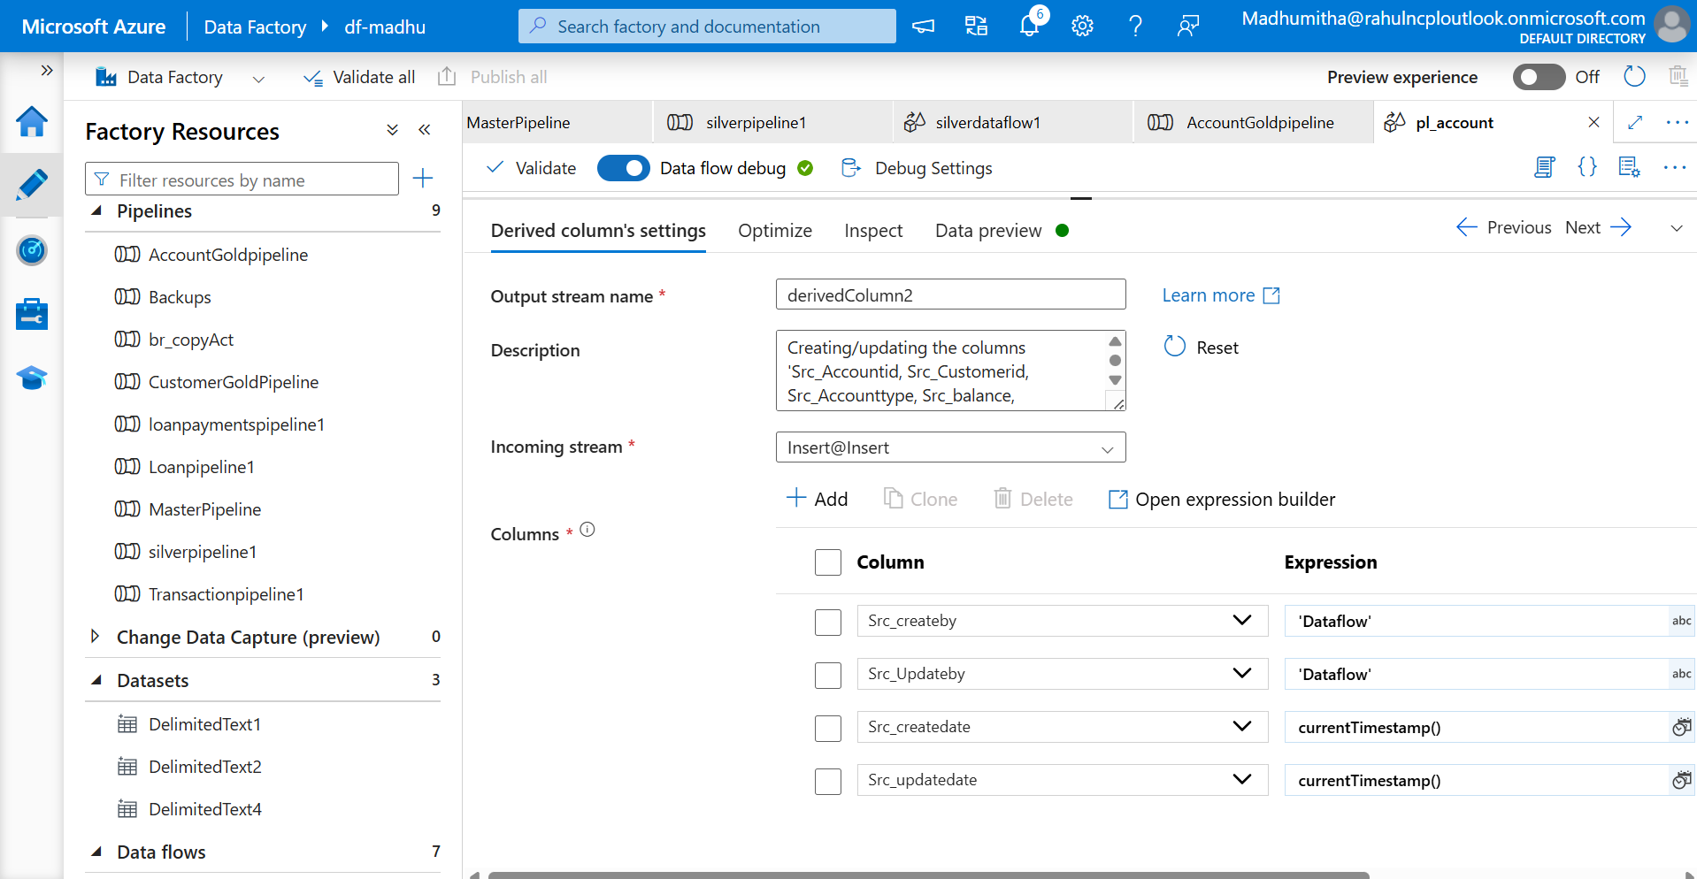

Sink Activity

Write the data to the targeted systems (SQL database)

Connect to linked service and datasets to send the transformed data.

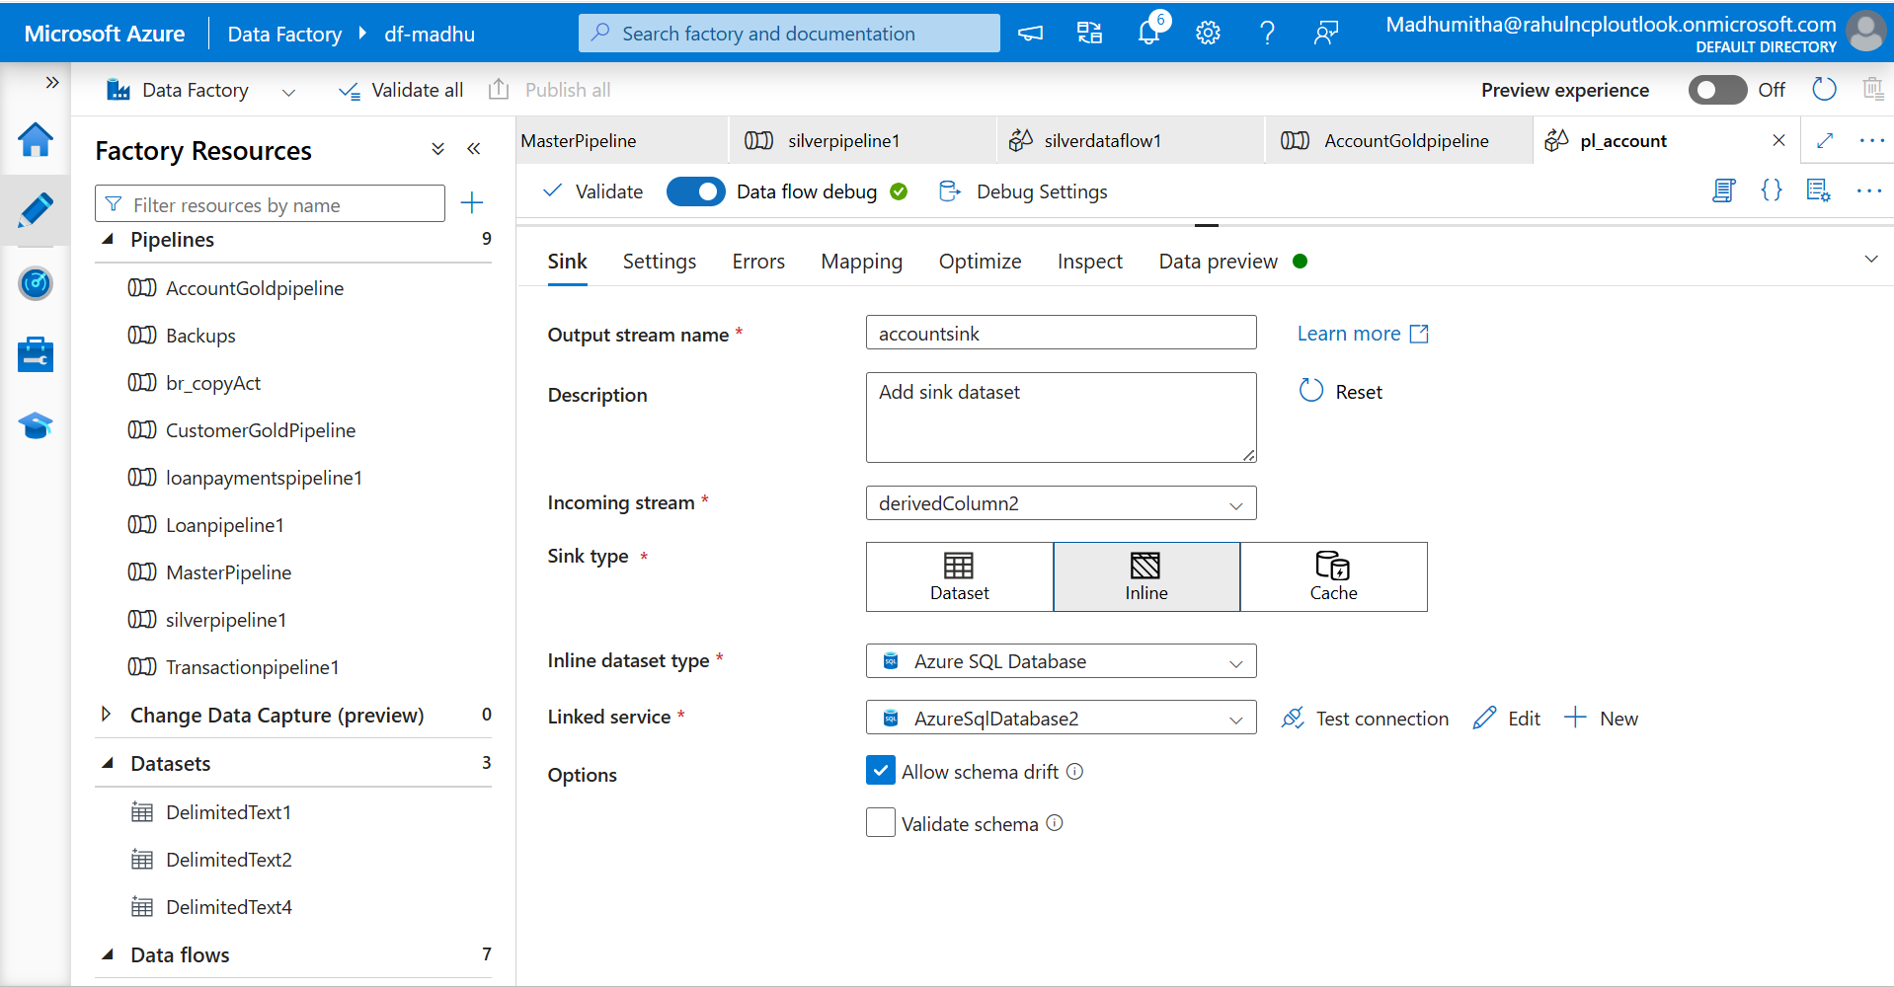

Mapping will map column-to-column between source and sink datasets

S10- Map the source column to target column and preview the data.

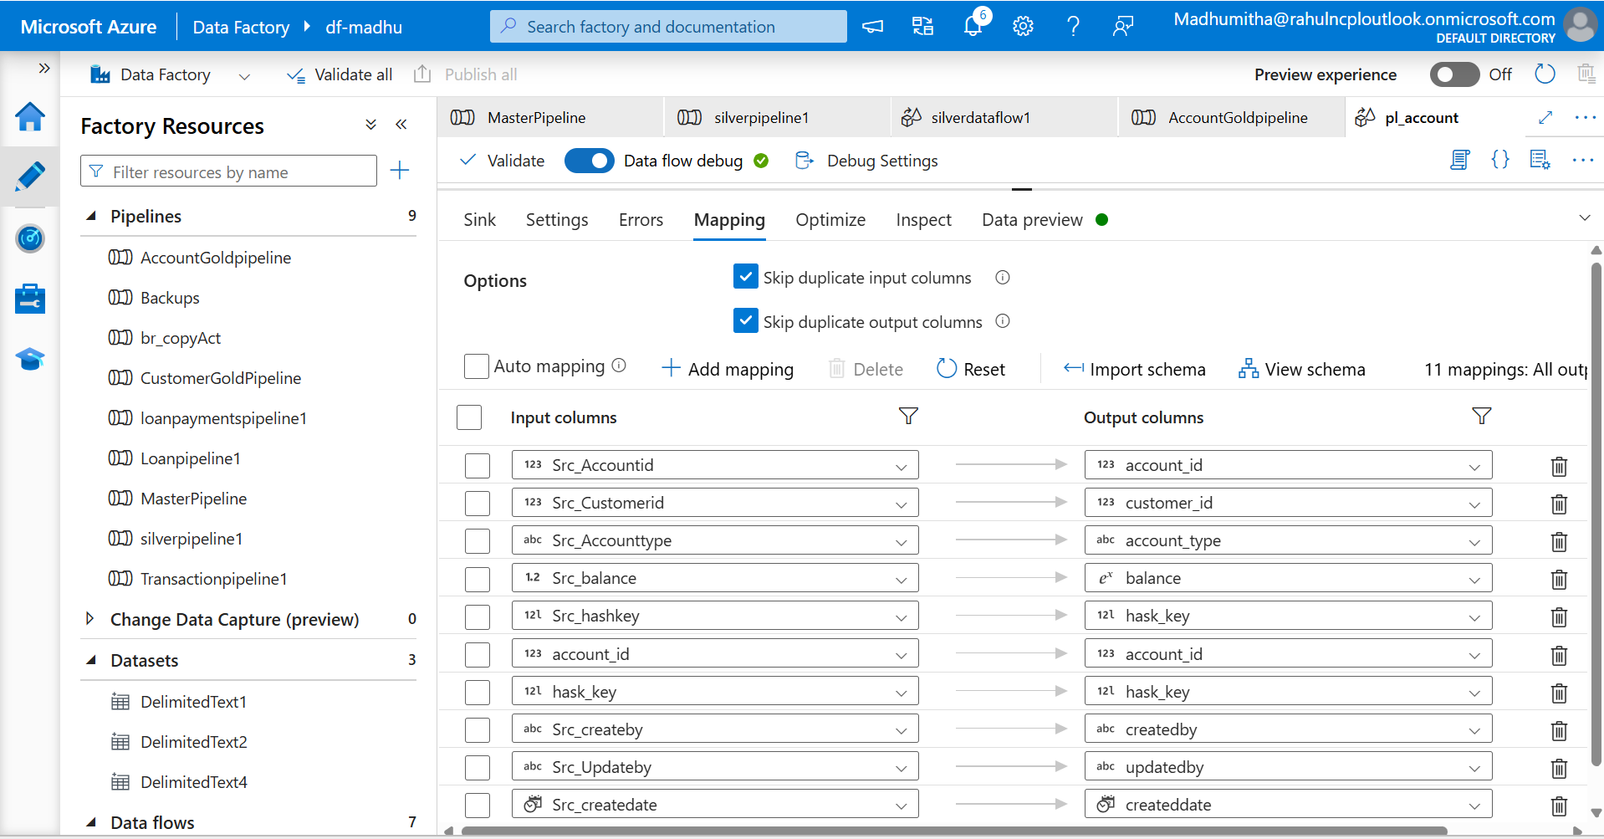

**AlterRow activity**

Add update if for update flow and 1==1 is the universal true condition in many programs.

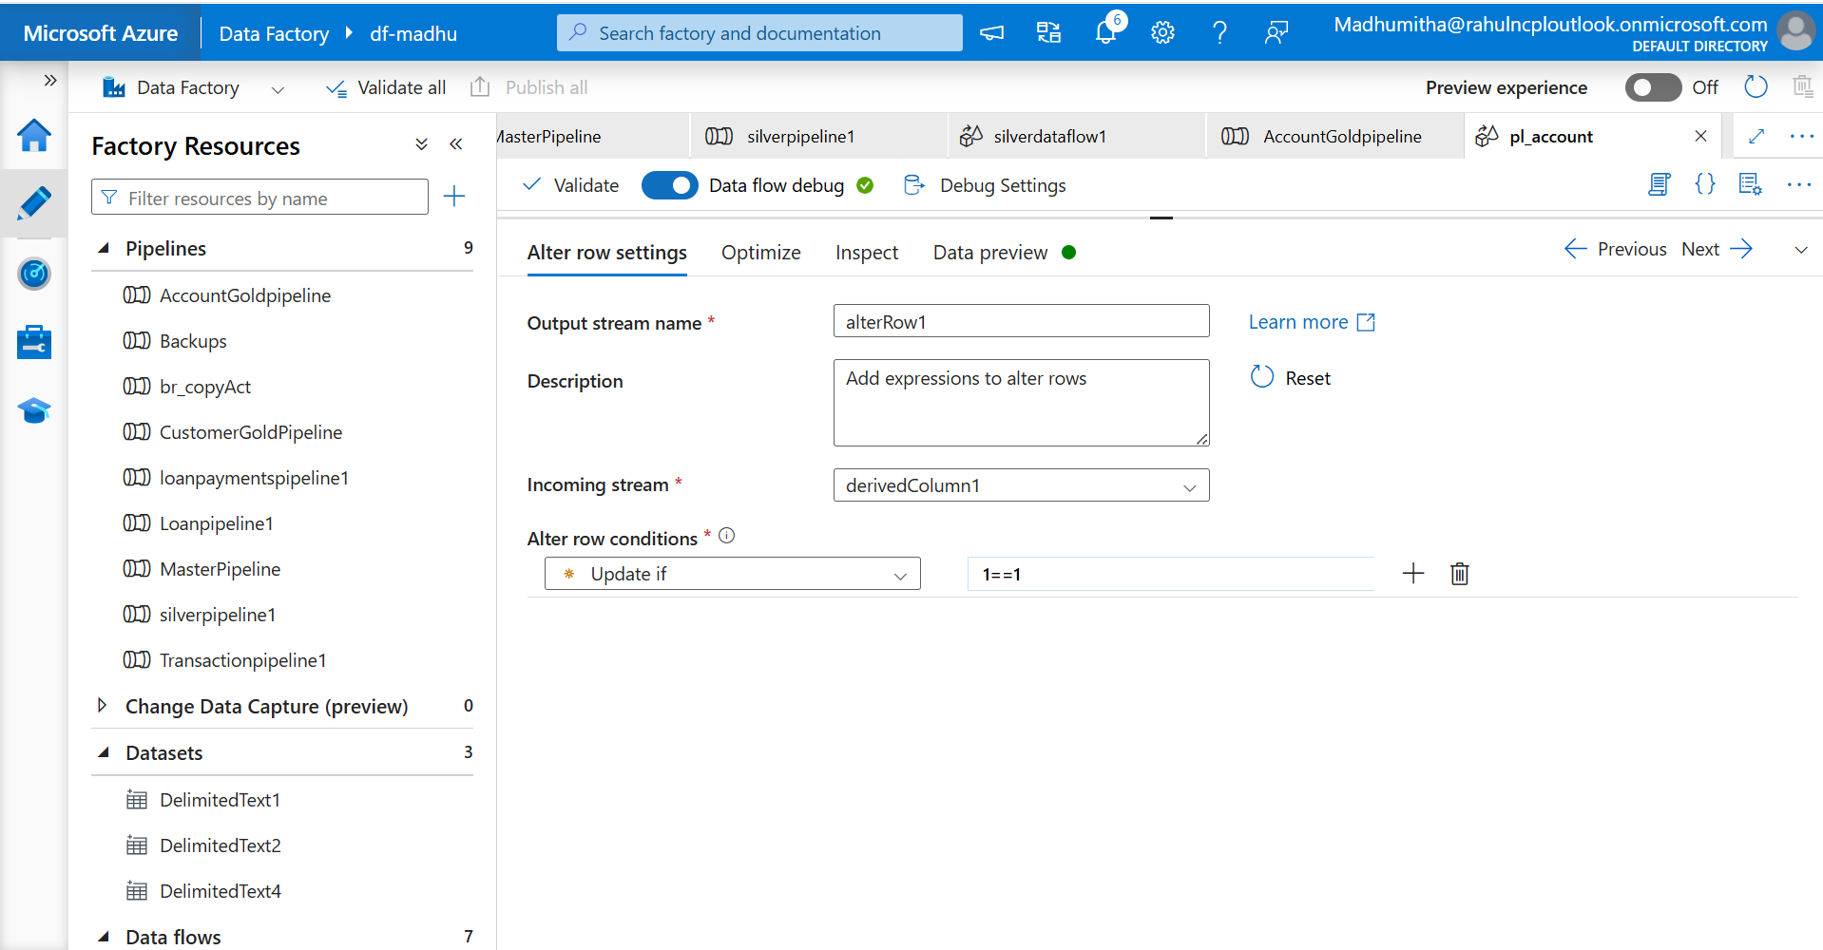

**SCD type 2**

Follow the steps for implementing SCD Type 1, and include additional steps to achieve SCD Type 2

Union Activity

Union activity will append the rows of multiple source.

S1- Set the incoming stream as @Insert and union with @Update.

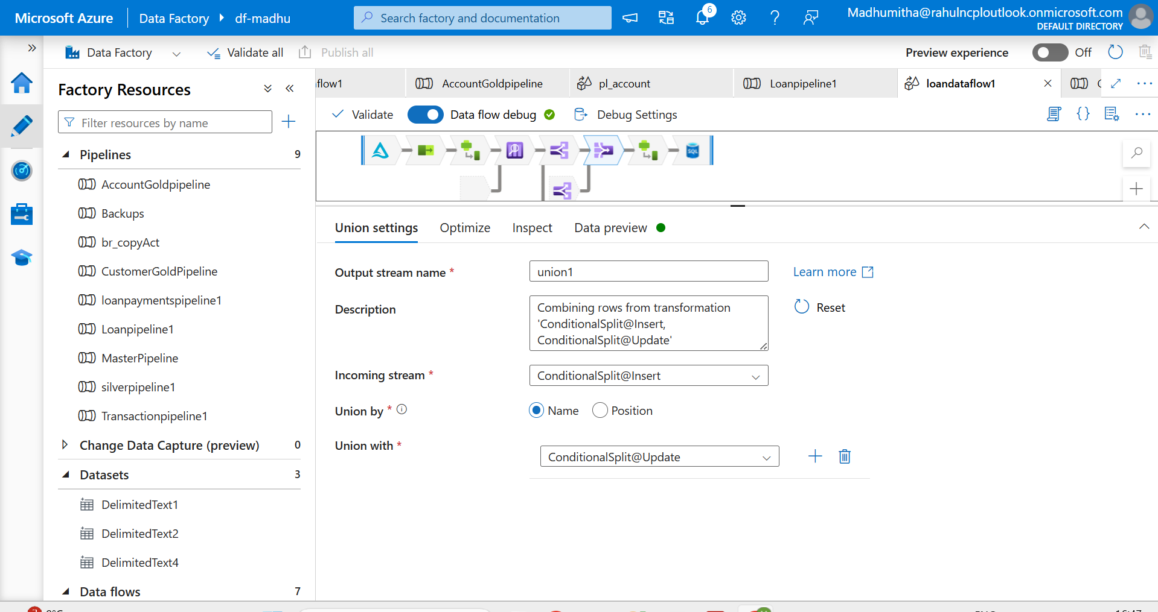

Insert->Derived activity

S9 – Add the expressions for createby,Updateby,Createdate,updatedate,isActive columns.

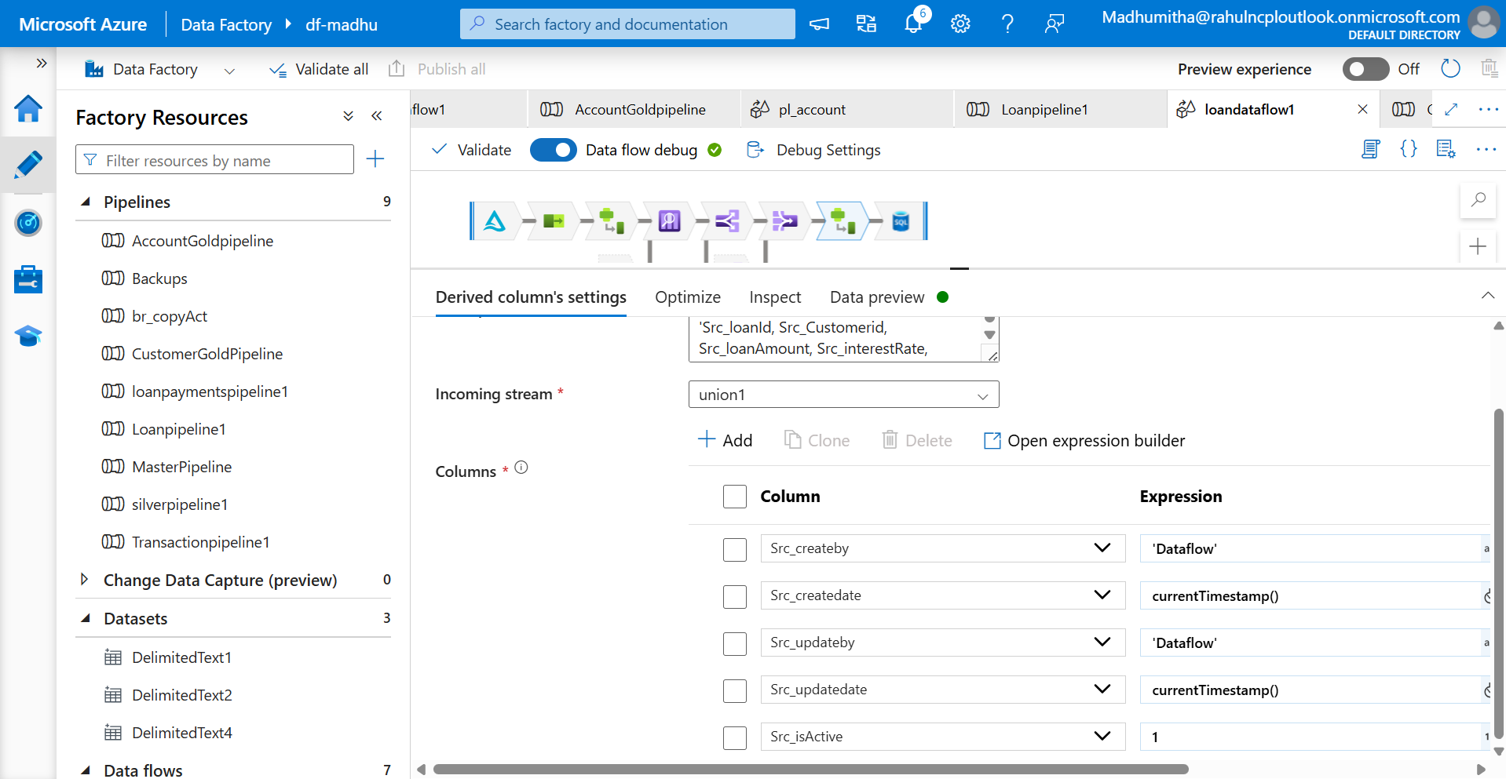

S10- Run all the 5 pipelines and check the data in SQL database

**Master pipeline**

The Execute pipeline activity use dataflows by splitting them into reusable components. You can design child pipeline and call them from a parent pipeline.

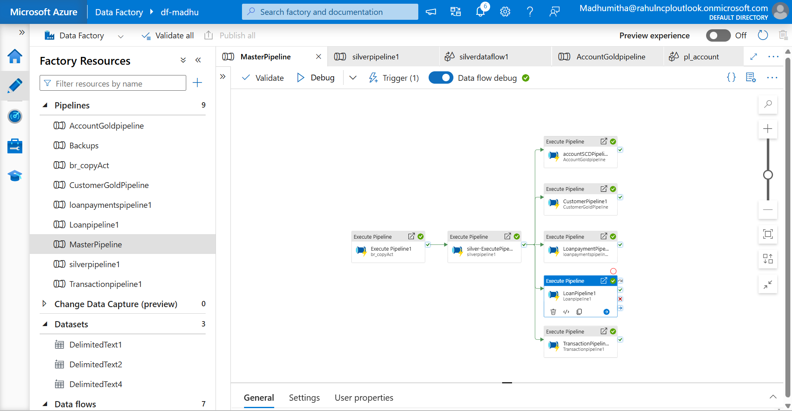

Gold layer Output-Insert

Accounts

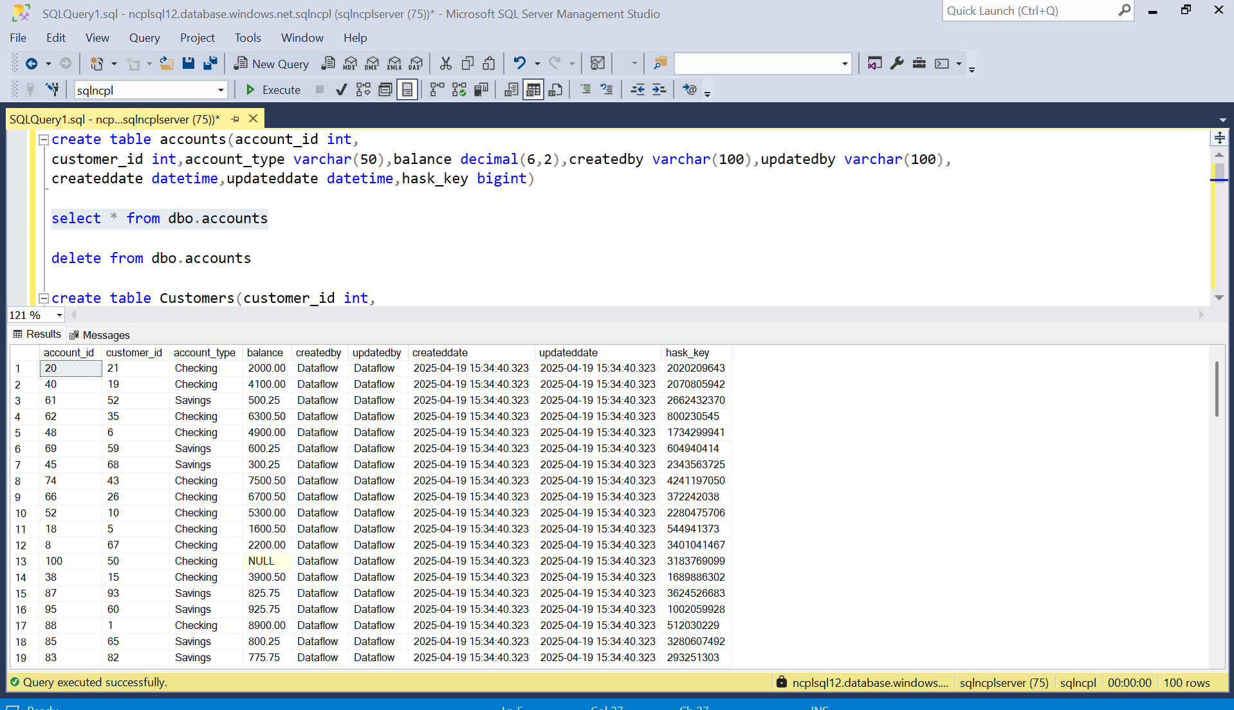

Customers

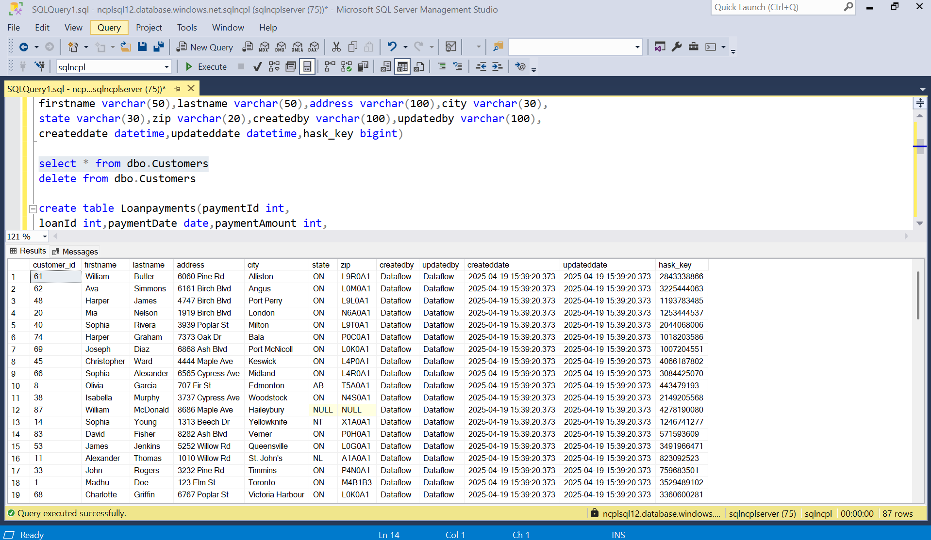

LoanPayments

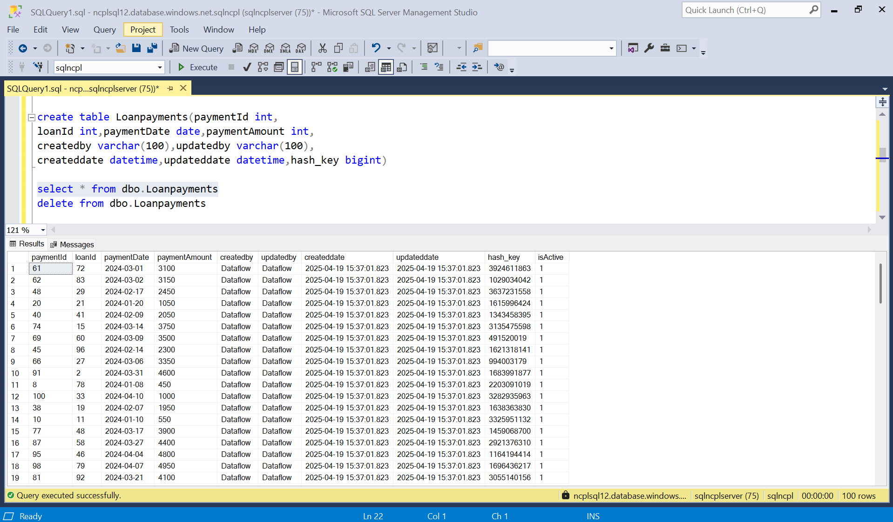

Loan

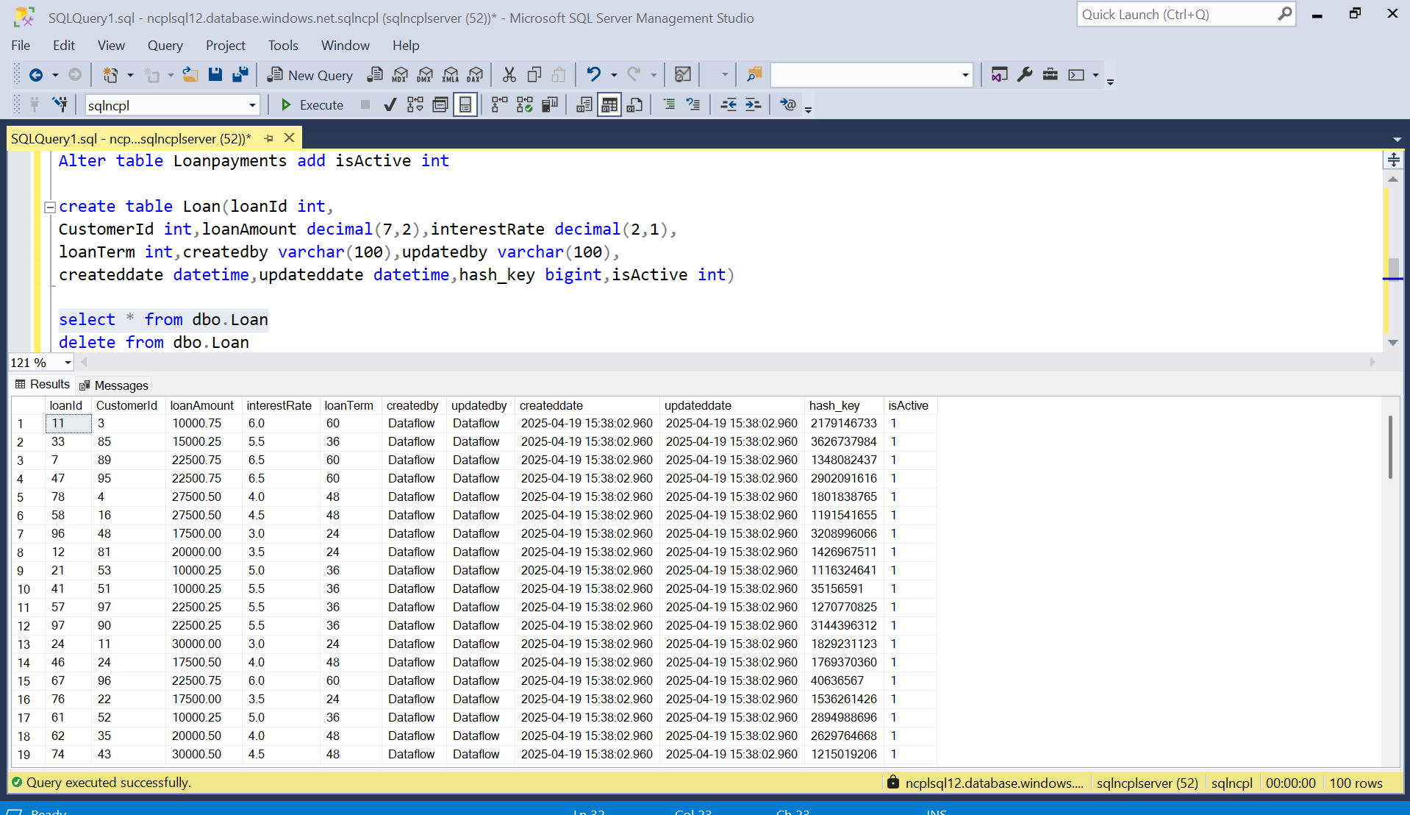

Transaction

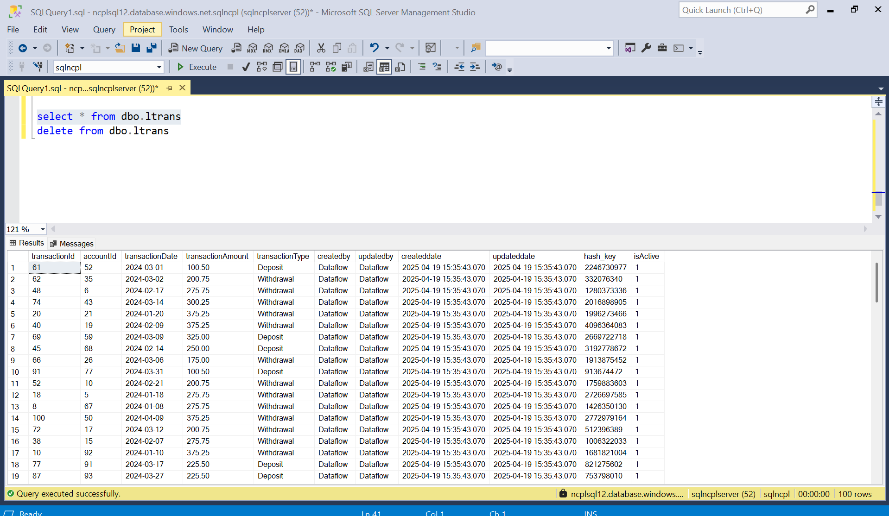

Update-Output

Accounts

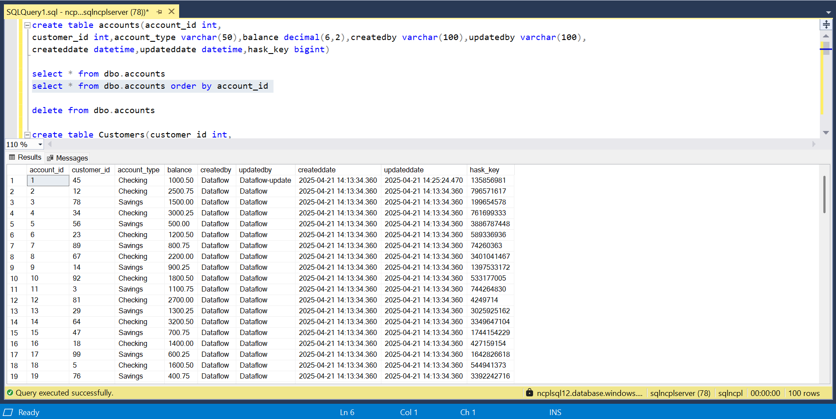

Customer

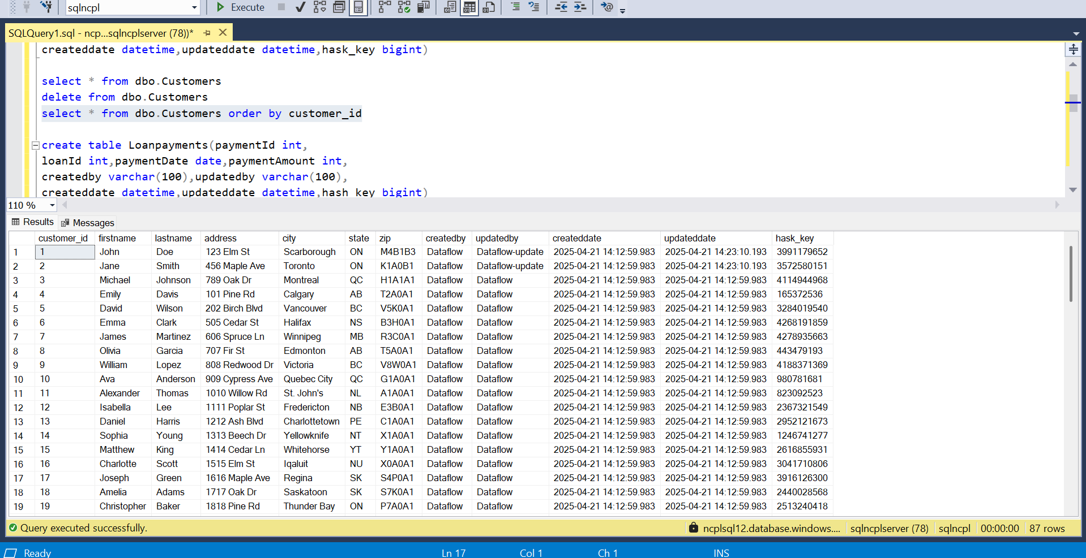

Loan payment

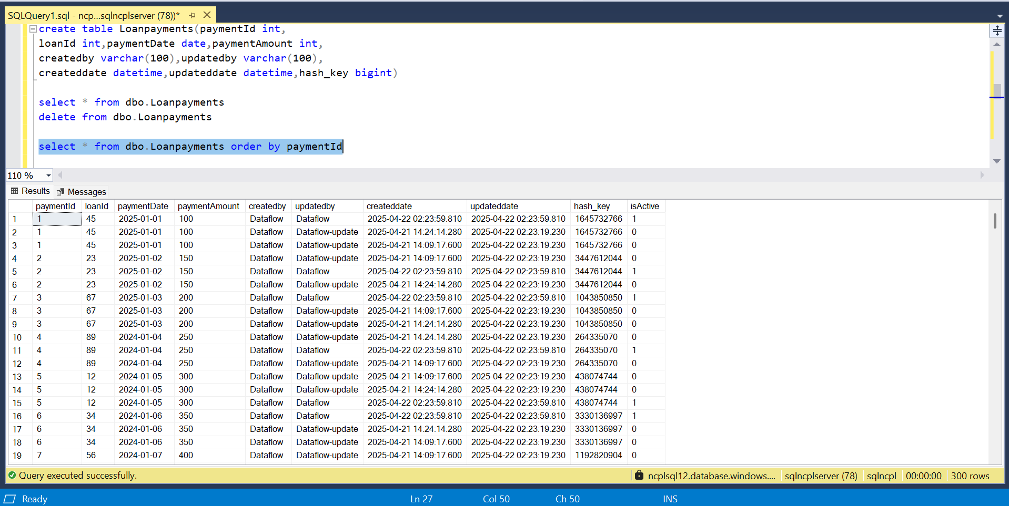

Loan

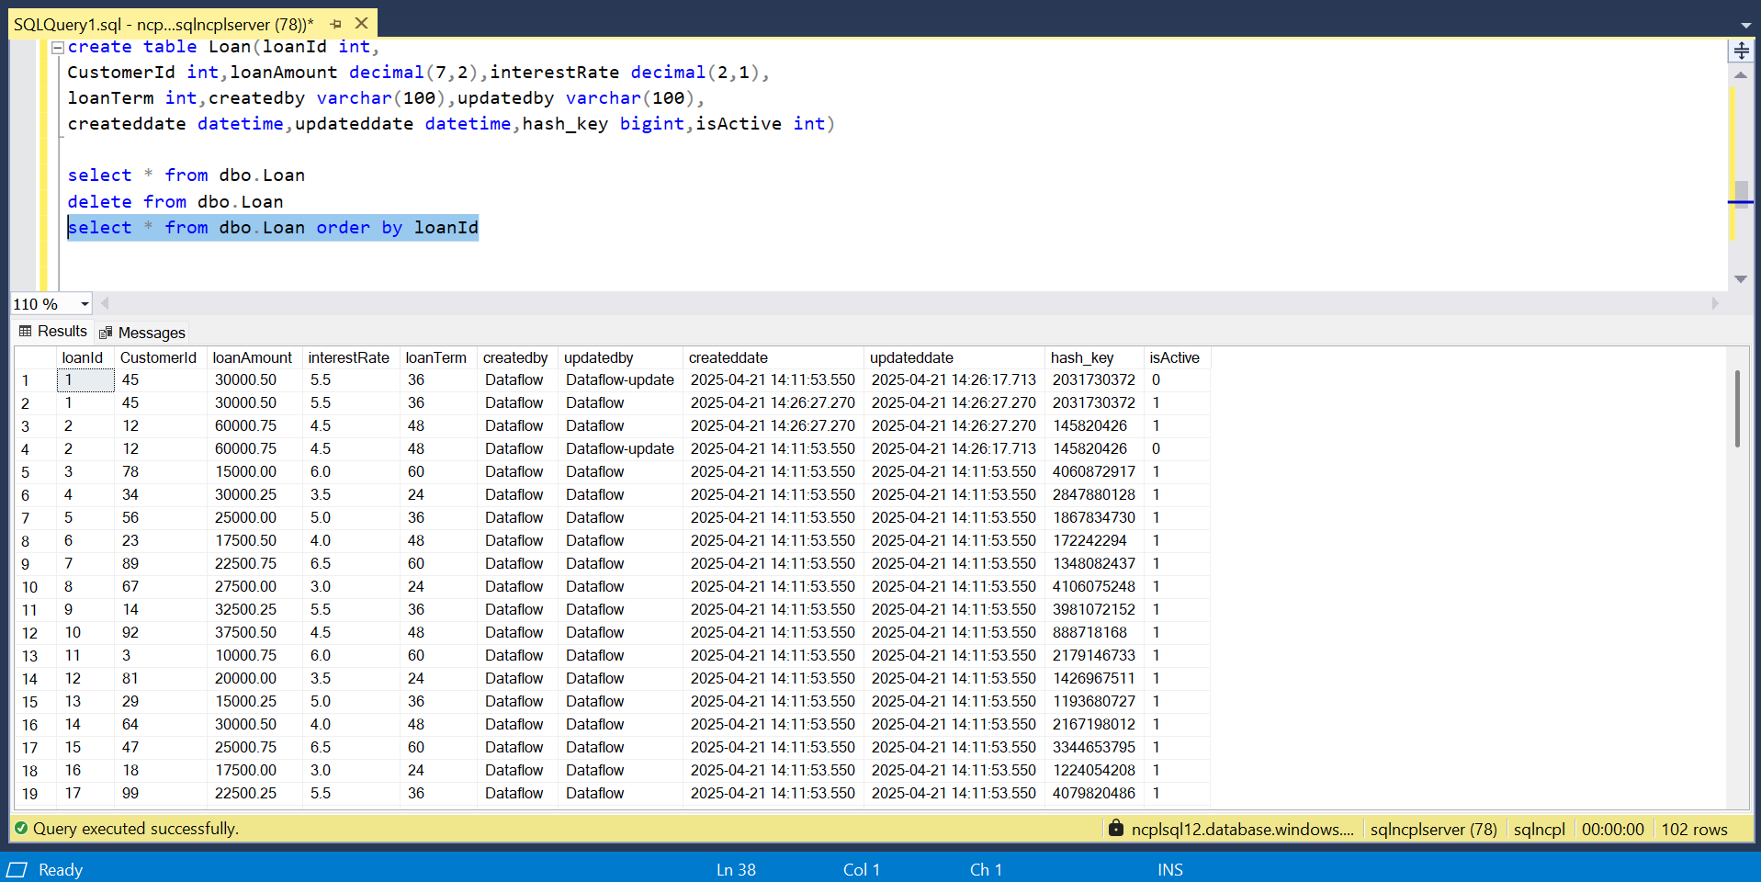

Transaction

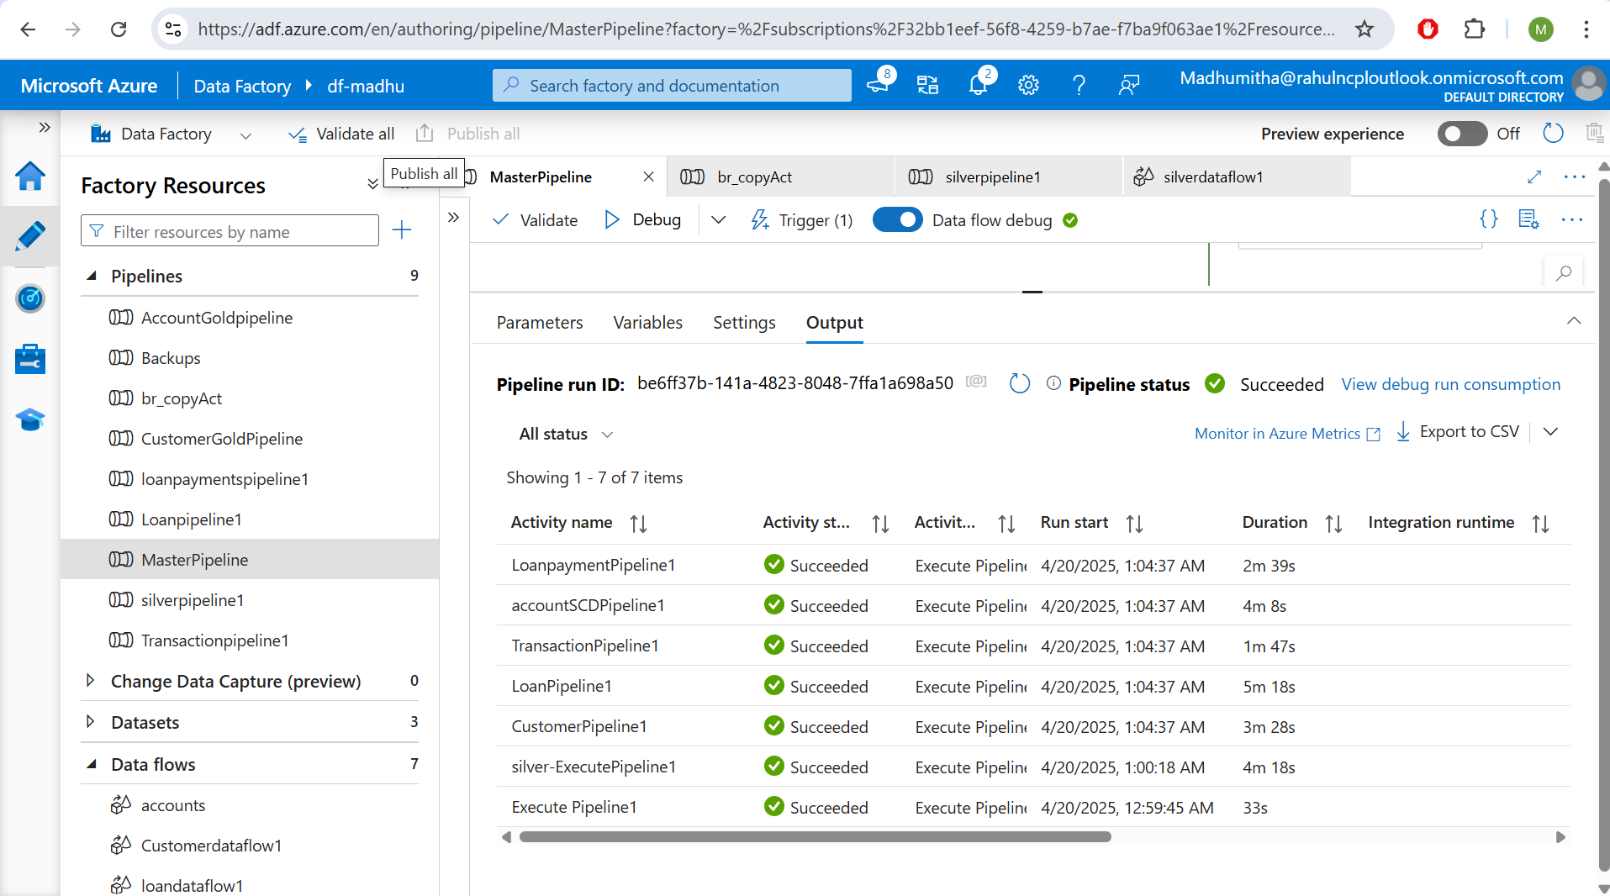

Update-O/P

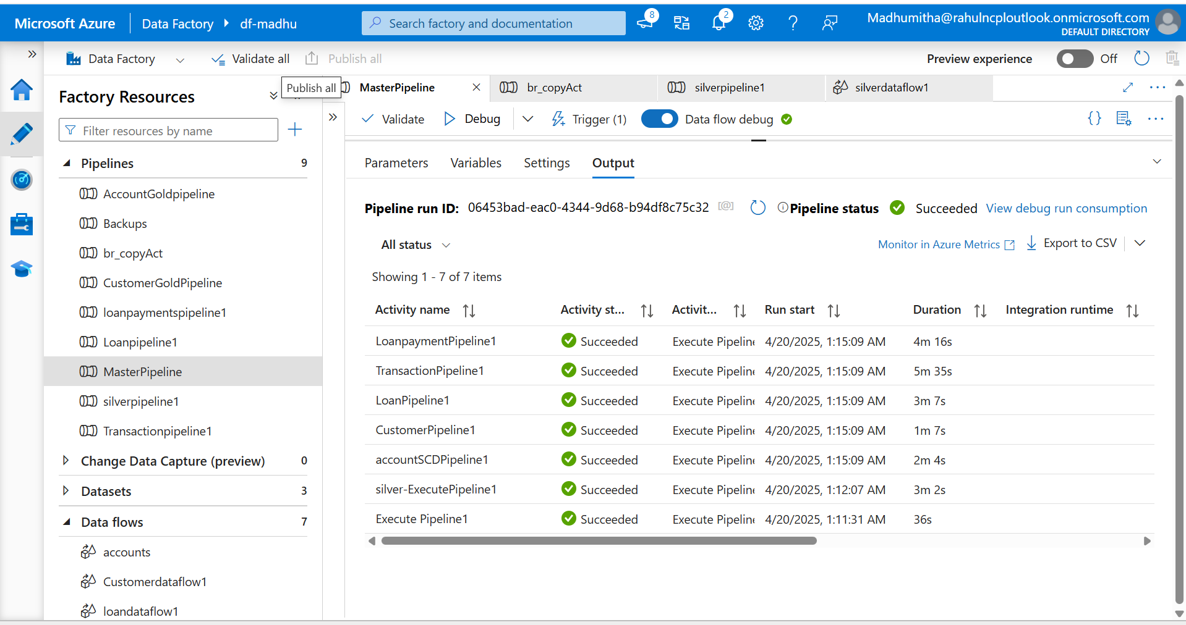

Insert-output

